**Documentation Guidelines**

**15CSE302 DBMS Project**

(1)Front page - Project name, Team name and details. (2)Table of contents

(3)Abstract

(4)Business rules

(5)Preview for the project

a. Introduction

b. Need and motivation

c. Tools used

(6)Project Analysis

a. List of modules in the project.

b. Module-wise explanation,

(7)Project Design

a. ER - Diagram

b. Database schema before normalization.

(8)Normalisation

a. Normalization procedure

b. Database schema after normalization

(9)Backend design

a. Table creation comments

b. Sample instances of the tables

(10) Frontend design

a. Introduction to the tool(s) (used in the project)

b. Screenshot (two screenshots in one page)

(11) Database connectivity

a. Introduction to the connectivity standard (used in the project) b. Connectivity code

(12) Sample code

a. Sample code of selected UI screens

(13) Conclusions

a. Elucidating important features of the project

(14) References

**Formatting Details**

(1) Font Type: Time New Roman.

(2) Font Size:

**Titles**: Times New Roman size 14 points.

**Subtitles**: Times New Roman 12 points.

**Content**: Times new Roman 11 points.

(3) Full Document should be justified.

(4) Pdf version of the document to be submitted.

Smart HealthCare- CSE A



BTech/III Year CSE/V Semester

15CSE302/Database Management Systems

Project Review -1

Group members:

|  |  |
| --- | --- |
| **Roll number** | **Name** |
| CB.EN.U4CSE18012 | Chavalam Nikhitha |
| CB.EN.U4CSE18037 | Nishita Dash |
| CB.EN.U4CSE18041 | Parripati Divyasri |
| CB.EN.U4CSE18042 | Parvana J Kuruppal |
| CB.EN.U4CSE18502 | Hridhi Sethi |

Table Of Contents

|  |  |  |
| --- | --- | --- |
| Sl.no | Title | Pg num |
| 1. | Abstract |  |
| 2. | Business Rules |  |
| 3. | Preview of Project |  |
| 4. | Project Analysis |  |
| 5. | Project design |  |
| 6. | Normalization |  |
| 7. | Backend design |  |
| 8. | Front end design |  |
| 9. | Database connectivity |  |
| 10. | Sample code |  |
| 11. | Conclusion |  |
| 12 | References |  |

Abstract

The idea here is to provide a platform to make the health care system more manageable and accessible for the patients, doctors and staff by maintaining a comprehensive database.  Maintaining proper health records, test reports, and prescriptions on a single platform makes the running of the system in place more effective and hassle free. Being DBMS based makes the updating, retrieval, backup etc of data easier in turn helping the doctors make timely and effective diagnosis. Online appointment system involved here helps save time and makes the actual process easier for the staff

Business Rules

The patients can update only their personal details, make appointments and view their prescriptions and results; they cannot alter their previous records or prescriptions and results; only doctors have the right to make changes to prescription in case of side effects of lack of availability. The admin can view and make changes to both the patient’s appointments as well as doctor’s schedule but cannot tamper with prescriptions and reports. Doctors need to request a change in schedule to admin if required.

Preview for Project

Introduction

The website is accessible to patients, doctors and administrative staff. A patient visiting the website can login if he is already registered at the hospital group or else he can sign up as a new patient. On signing up the patient will be prompted to update his health records and fill the required information for finishing the registration. After completing the set up the patient can fix an appointment with an allotted physician on the available date, the physician will then further recommend a specialist if required and the patient will be given an appointment for the same. After consultation the prescription will be made available on the patient's page along with the diagnosis and results of lab tests if any were performed. The lab results and prescriptions will be accessible to doctor as well as patients and only doctor is given the permission to alter prescription. The patient can check availability of the required medicine on the website as well but will be allowed to place an order for it only if the patient has a valid prescription.

Administrative staff can access the patient’s appointment request and doctor’s schedule and accordingly fix the required appointment, all updates with regard to this will also be performed by them, they are responsible for updating the test results and prescriptions onto the database and keeping inventory of the medicines available at the pharmacy after consulting with the pharmacy. The payment transaction and billing is also handled under this department.

The Smart Health Care System increases the hospital chain’s effectiveness and quality of work while increasing the ease of functioning by interconnecting the databases of different departments while making sure the data is secure.

Need and Motivation

To build a website that manages data and provides a certain collection of functionalities to patients, doctors and staff of a particular hospital group. The objective is to make tasks such as making appointments, viewing past health records, updating records, viewing prescriptions and test results, checking availability of prescribed medicine etc possible from the comfort of their homes. Similarly, doctors can view or modify their schedules, view their patient ‘s records and test results on this platform. Healthcare is a field in which accurate record keeping and communication are critical and our project tries to achieve the same.

Tools used

UI design - React JS

Backend - Express JS and Node JS

Database - My SQL workbench

Design - Dia tool

Project Analysis

List of modules and explanation

## Attributes

1. Person(pe_adhaar_number,pe_phoneno,pe_age,pe_gender,pe_city,pe_state,pe_street_name,pe_zip,br_id(FK),L_id(FK));
2. Patient(p_disease,p_id, pe_adhaar_number(FK));
3. Doctor (D_id,D_specialization ,D_salary, pe_adhaar_number(FK));
4. Patient_consults_doctor(p_id(FK), D_id(FK),ins_id(FK));
5. Test_report(test_name,test_category,test_doc,ts_id(FK),p_(FK));
6. Medical_history(med_allergy,med_past,med_current,p_id(FK),pr_id(FK));
7. Diagnosis(dag_id,dag_category,dag_admitted,p_id(FK)
8. Payments(pay_id,pay_amount,pay_satus,pay_date,pay_method,p_id(FK));
9. Login_Details(L_id,L_usern,L_pass,L_category);
10. Branches(br_id,br_city,br_state,br_pincode,br_street_name);
11. Medicine(med_id,med_status,med_name,med_price,med_category,br_id(FK));
12. Tests(ts_id,ts_name,ts_available,ts_status,eq_id(FK));
13. Insurance(ins_id,insco_name,ins_category);
14. Test_req_inventory(eq_id(FK),ts_id(FK));
15. Prescription(pr_id,pr_status,dag_id(FK),test_id(FK));
16. Appointments(app_id,app_time,app_date,p_id(FK),d_id(FK));
17. Inventory(eq_name,eq_id,eq_status,eq_number,br_id(FK));
18. Tests_branches(ts_id(FK),br_id(FK));

## Relationships

1. Patient_consults_doctor
2. Patient_test_report
3. Patient_diagnosis
4. Patient_medical_history
5. Patient_insurance
6. Patient_appointment
7. Doctor_sets_appointment
8. Person_login
9. Branch_person
10. Branch_inventory
11. Branch_available_medicine
12. Test_req_inventory
13. Priscription_test_rep
14. Prescription_diagnosis
15. Medical_history_prescription
16. Patient_prescription
17. Pay_bills
18. Derived_from

Project Design

ER Diagram

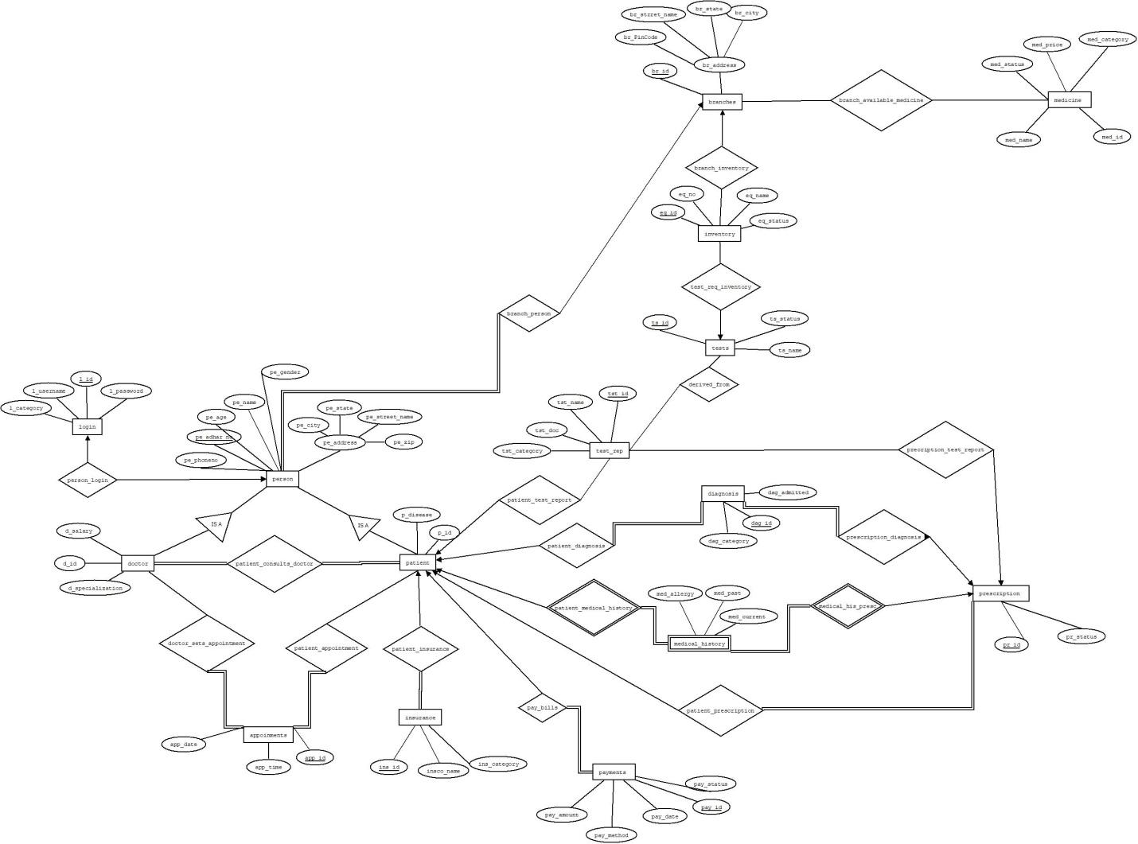

Database Schema

1)    Person(pe_adhaar_number,pe_phoneno,pe_age,pe_gender,pe_city,pe_state,pe_street_name,pe_zip,br_id(FK),L_id(FK));

2)     Patient(p_disease,p_id, pe_adhaar_number(FK));

3)     Doctor (D_id,D_specialization ,D_salary, pe_adhaar_number(FK));

4)     Patient_consults_doctor(p_id(FK), D_id(FK),ins_id(FK));

5)     Test_report(test_id,test_name,test_category,test_doc,ts_id(FK),p_(FK));

6)     Medical_history(med_allergy,med_past,med_current,p_id(FK),pr_id(FK));

7)     Diagnosis(dag_id,dag_category,dag_admitted,p_id(FK)

8)     Payments(pay_id,pay_amount,pay_satus,pay_date,pay_method,p_id(FK));

9)     Login_Details(L_id,L_usern,L_pass,L_category);

10)  Branches(br_id,br_city,br_state,br_pincode,br_street_name);

11)  Medicine(med_id,med_status,med_name,med_price,med_category,br_id(FK));

12)  Tests(ts_id,ts_name,ts_available,ts_status,eq_id(FK));

13)  Insurance(ins_id,insco_name,ins_category);

14)  Test_req_inventory(eq_id(FK),ts_id(FK));

15)  Prescription(pr_id,pr_status,dag_id(FK),test_id(FK));

16)  Appointments(app_id,app_time,app_date,p_id(FK),d_id(FK));

17)  Inventory(eq_name,eq_id,eq_status,eq_number,br_id(FK));

18)  Tests_branches(ts_id(FK),br_id(FK));

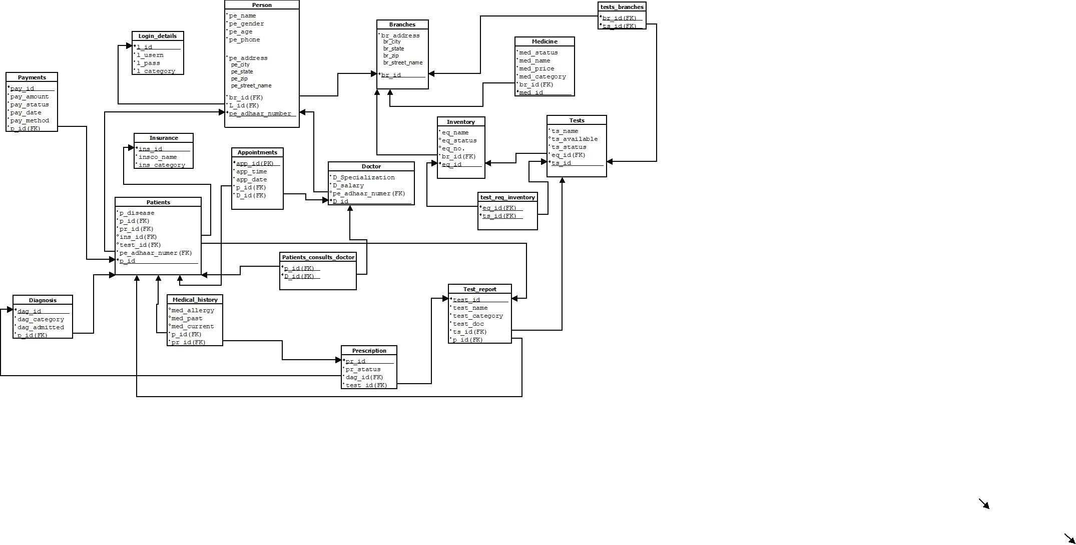

Normalization

Normalization Procedure

CHECKING 1NF

Since there are no Multivalued attributes ,no two columns have the same values and the table has an identified composite primary key , it satisfies first normal form.

CHECKING 2NF

Since parts of the composite primary key determines different non-prime attributes, partial dependencies exist and therefore the relation is not in 2nd normal form. To convert it to 2nd normal form, the relation Smart_health_care can be split into 16 different relations .Tables after decomposition:

Patient (p_id , p_disease, p_name, p_gender, p_phone, p_city, p_state, p_zip,p_age, p_street_name, p_city,p_state,br_id,l_id)

doctor(d_id,d_name, d_gender, d_phone, d_city, d_state, d_zip, d_street_name, Br_id, l_id, d_salary,d_specialization,d_city, d_state,br_id,l_id)

AdminStaff(ad_id,ad_name, ad_gender,ad_phone, ad_zip, ad_street_name,ad_city,Br_id,L _id, ad_salary,ad_statebr_id,l_id)

Login Details(l_id, l_usern,l_pass,l_category)

Insurance(ins_id,ins_category,p_id,ins_co_name,p_id)

Appointments(app_id, app_time, app_date,d_id,p_id)

diagnosis(dag_id, dag_category, dag_admitted,p_id,pr_id)

Medical history_1(pr_id, med_allergy, p_id, med_current)

Medical history_2(p_id, med_past)

Prescription(pr_id, pr_status, p_id, test_id)

payments(pay_id, pay_amount,pay_staus,pay_date,pay_method, p_id)

branches(br_id, br_city, br_state, br_zip, br_street_name)

tests(ts_id, ts_name, ts_available, eq_id)

test_report(test_id, test_name, ts_id, test_doc, test_category)

Medicine (med_id, med_status, med_name, med_price, med_category, br_id)

inventory(eq_id, eq_name, eq_staus, eq_no, br_id)

CHECKING 3NF

Since multiple non-prime attributes determine other non-prime attributes Transitive Dependencies exist and therefore the relations are not in 3rd normal form.

Patient_1 (p_id , p_disease, p_name, p_gender, p_phone, p_zip,p_age, p_street_name, p_city,p_state,br_id,l_id)

Patient_2(p_zip,p_city)

Patient_3(p_city, p_state)

doctor_1(d_id,d_name, d_gender, d_phone, d_city, d_state, d_zip, d_street_name, Br_id, l_id, d_salary,d_specialization,br_id,l_id)

doctor_2(d_zip,d_city)

doctor_3(d_city, d_state)

AdminStaff_1(ad_id,ad_name, ad_gender,ad_phone, ad_zip, ad_street_name,Br_id,L _id, ad_salary,br_id,l_id)

Adminstaff_2(ad_zip,ad_city)

adminstaff_3(ad_city,ad_state)

Login Details_1(l_id, l_usern)

Login Details_2(l_usern,l_pass,l_category)

Insurance_1(ins_id,p_id)

Insurance_2(p_id, ins_co_name,ins_category)

Appointments(app_id, app_time, app_date,d_id,p_id)

diagnosis(dag_id, dag_category, dag_admitted,p_id,pr_id)

Medical history_1(pr_id, med_allergy, p_id, med_current)

Medical history_2(p_id, med_past)

Prescription(pr_id, pr_status, p_id, test_id)

payments(pay_id, pay_amount,pay_staus,pay_date,pay_method, p_id)

branches_1(br_id, br_zip, br_street_name)

branches_2( br_zip,br_city, br_state)

branches_3(br_city,br_state)

tests_1(ts_id, ts_name, ts_available)

tests_2(ts_name, eq_id)

test_report_1(test_id, test_name, ts_id, test_doc)

test_report_2(test_name, test_category)

Medicine_1( med_name, med_status, med_price, med_category)

Medicine_2(med_id, med_name,br_id)

inventory(eq_id, eq_name, eq_staus, eq_no, br_id)

CHECKING BCNF:

It satisfies BCNF because determinants are candidate keys.

Schema after normalization

* patient_1->(p_idr, p_name, p_gender, p_phone, p_zip, p_street_name,p_disease, Br_id, l_id)
* patient_2->(p_city,p_zip)
* patinet_3->(p_city,p_state)
* doctor_1->(d_id, d_adhaar_number, d_name, d_gender, d_phone, d_zip, d_street_name, d_salary , d_specialization, Br_id, l_id)
* doctor_2->(d_city, d_zip)
* doctor_3->(d_city, d_state)
* admin_1->(ad_id, ad_name, ad_gender, ad_phone, ad_zip, ad_street_name, ad_salary , ad_specialization, Br_id, l_id)
* admin_2->( ad_city,ad_zip)
* admin_3->( ad_state,ad_city)
* login_details_1->( l_id, l_usern)
* login_details_2->( l_pass, l_category,l_usern)
* insurance_1->(ins_id, p_id)
* insurance_2->(p_id,ins_co_name, ins_category)
* appointments->(app_id, app_time, app_date, p_id,d_id)
* diagnosis->(dag_id, dag_category, dag_admitted, p_id, pr_id)
* Medical history_1->(med_allergy, pr_id,med_current, p_id )
* Medical history_2->(p_id, med_past)
* prescription-> (pr_id, pr_status, p_id, test_id)
* payments->(pay_id, pay_amount, pay_status, pay_date, pay_method, p_id)
* branches_1-> ( br_id,br_zip, br_street_name)
* branches_2->(br_city, br_state,br_zip)
* tests_1->(ts_id, ts_name, ts_available)
* tests_2->(ts_name, eq_id)
* test_report_1->( test_name, test_category)
* test_report_2->(test_id, test_doc,test_name,ts_id)
* medicine_1->(med_name,med_statu, med_price, med_category)
* medicine_2->(med_id,med_name, br_id)
* inventory->(eq_id, eq_name, eq_staus, eq_no, br_id)
* prescription_test_report->(test_id,pr_id)
* patients_consults_doctor->(p_id,d_id)
* patients_test_report->(p_id, test_id)
* branch_available_medicine(br_id,med_id)
* test_req_inventory->(eq_id,ts_id)

Backend Design

Table Creations

create table med_history(p_id integer references patient_details(p_id),pr_id integer references prescription(pr_id),med_allergy varchar(800),med_current varchar(800),med_past varchar(800),CONSTRAINT pk_medhistory PRIMARY KEY (p_id));

Create table prescription(pr_id integer primary key AUTO_INCREMENT,pr_status varchar(255), p_id integer REFERENCES patient_details(p_id),test_id integer REFERENCES test_report (test_id));

Create table test_report(test_id integer primary key AUTO_INCREMENT,test_name varchar(255),test_doc varchar(255),ts_id varchar(255) references tests(ts_id),test_category varchar(255), p_id integer references patient_details(p_id));

create table payments(pay_id integer primary key auto_increment,pay_amount float,pay_status varchar(255),pay_date varchar(255),pay_method varchar(255),p_id integer references patient_details(p_id) );

create table doctor(d_id integer primary key auto_increment,d_name varchar(255),d_gender varchar(255),d_specialization varchar(255),d_phone integer,d_zip integer,d_age integer,d_salary float,d_street_name varchar(255),br_id integer,l_id integer,d_city varchar(255),d_state varchar(255),foreign key (br_id) references branches(br_id),foreign key (l_id) references login_details(l_id));

create table appointments(app_id integer primary key auto_increment,app_time time,app_date date,descp varchar(1000),p_id integer references patient_details(p_id),d_id integer references doctor(d_id));

Create table insurance(ins_id integer primary key auto_increment,p_id integer REFERENCES patient_details(p_id),ins_name varchar(255),ins_category varchar(255));

create table medicine(med_id integer primary key auto_increment ,med_name varchar(255) ,med_status varchar(255),med_price float,med_category varchar(255),br_id integer references branches(br_id));

create table login_details(l_id integer primary key AUTO_INCREMENT, l_usern varchar(255),l_pass varchar(255),l_category varchar(255));

create table branches(br_id integer primary key, br_city varchar(255),br_state varchar(255));

Table Insertions

Tests:

Insert into tests values('t01','blood test','available',301);

Insert into tests values('t06','biopse','not available',302);

Insert into tests values('t12','ct scan','available',209);

Insert into tests values('t64','x-ray','available',202);

Insert into tests values('t57','polymerase chain reaction','not available',306);

Insert into tests values('t58','prothrombin time','available',305);

Insert into tests values('t63','cardiac enzymes','available',307);

Insert into tests values('t76','calcium blood test','available',308);

Insert into tests values('t20','folate test','not available',309);

Insert into tests values('t11','tsh','available',400);

Inventory:

insert into inventory values(201,'syringe','available',20,302);

insert into inventory values(202,'x-ray','unavailable',4,305);

insert into inventory values(206,'Ultrasonography machine','available',2,303);

insert into inventory values(209,'CT scan','unavailable',1,303);

insert into inventory values(304,'test tubes','available',300,301);

Insert into inventory values (244,'glucometer','unavailable',6,306);

Insert into inventory values (546,'radiometer','available',8,305);

Insert into inventory values (789,'pneumograph','available',10,301);

Insert into inventory values (290,'Sterilizer','available',5,308);

Insert into inventory values (126,'handle-o-meter','unavailable',5,310);

Branches:

Insert into branches values(101,'agra','uttar pradesh');

Insert into branches values (102,'kolkata','west bengal');

Insert into branches values (103,'alappuzha','kerala');

Insert into branches values(104,'amritsar','punjab');

Insert into branches values (105,'vijayawada','andhra pradesh');

Insert into branches values (106,'chennai','tamil nadu');

Insert into branches values (107,'vadodara','gujarat');

Insert into branches values (108,'bhubaneswar','orissa');

Insert into branches values (109,'guwahati','assam');

Insert into branches values(110,'gurgaon','haryana');

Login details:

insert into login_details values(9008,'arnc','arnie','doctor');

insert into login_details values(9009,'piyush','pc2000','doctor');

insert into login_details values(9010,'priya','nickjonas','doctor');

insert into login_details values(9011,'jitam','mohapatrajita','doctor');

insert into login_details values(9012,'disha123','disham','doctor');

insert into login_details values(9013,'adarsh','pubg','doctor');

insert into login_details values(9014,'manish','manish1','doctor');

insert into login_details values(9015,'atrayee','arjun','doctor');

insert into login_details values(9016,'bhaskar','sun','doctor');

insert into login_details values(9017,'manan','manman','doctor');

insert into login_details values(9018,'jahnvi','janu','doctor');

insert into login_details values(9019,'mehr','mehrmein','doctor');

insert into login_details values(9020,'12452','singhal','doctor');

insert into login_details values(900000,'Sharad','dondon','staff');

insert into login_details values(900001,'rada','iamstaff','staff');

insert into login_details values(900002,'Sharada','xyz2','staff');

Admin staff

insert into adminstaff values(300,'Sharad','Male',55,9056752189,'Chopat nagar',101,900000,200000,520008,'agra','uttar pradesh');

insert into adminstaff values(301,'rada','female',55,9056752189,'Chopat nagar',102,900001,200000,520008,'kolkata','west bengal');

insert into adminstaff values(302,'Sharada','female',55,9056752189,'Chopat nagar',101,900002,200000,520008,'agra','uttar pradesh');

Medicine:

insert into medicine values(1452,'avomine','available',15,'nausea',101);

insert into medicine values(1992,'keraglo','unavailable',200,'supplement',102);

insert into medicine values(1765,'dart','available',70,'painkiller',103);

insert into medicine values(1993,'adderall','available',100,'ADHD',102);

insert into medicine values(1578,'acetaminophen','available',150,'painkiller',104);

insert into medicine values(1094,'ampicillin','available',59,'bacterial infection',103);

insert into medicine values(1286,' crocin','unavailable', 29 ,'headache',106);

insert into medicine values(1568,'nise','available',23 ,'body pains',105);

insert into medicine values(1123,'dolo','available', 65,'fever',101);

insert into medicine values(1679,'dsr', 'available' ,20 ,'diabetes',106);

Insurance :

insert into insurance values(7889,200000,'Birla Life insurance','platinum') ;

insert into insurance values(1438,200001,'SBI life insurance','gold') ;

insert into insurance values (1223,200003,'Excite life insurance','gold');

Front end design

Introduction to tools

We have made use of REACT JS to design 20 pages mimicking the working of a Smart health Care System.  
React JS is a JavaScript library that forces you to think in terms of components. This model of thinking fits user interfaces well especially  
in a project as vast as this.

User Interface:

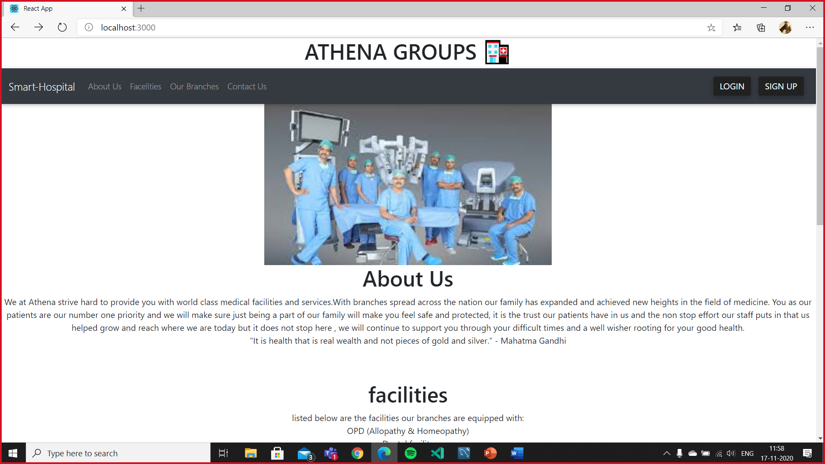

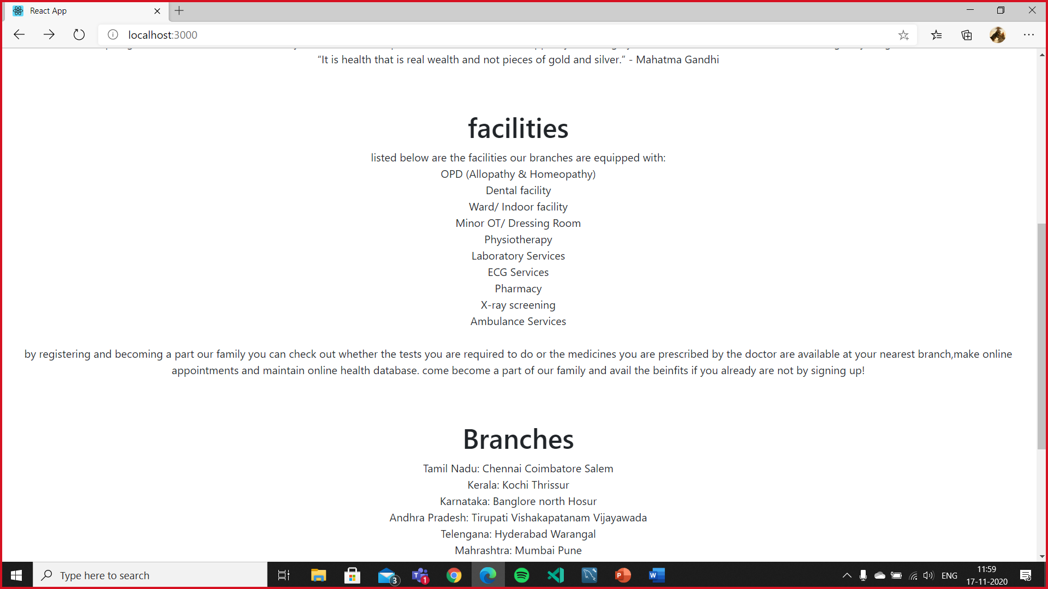

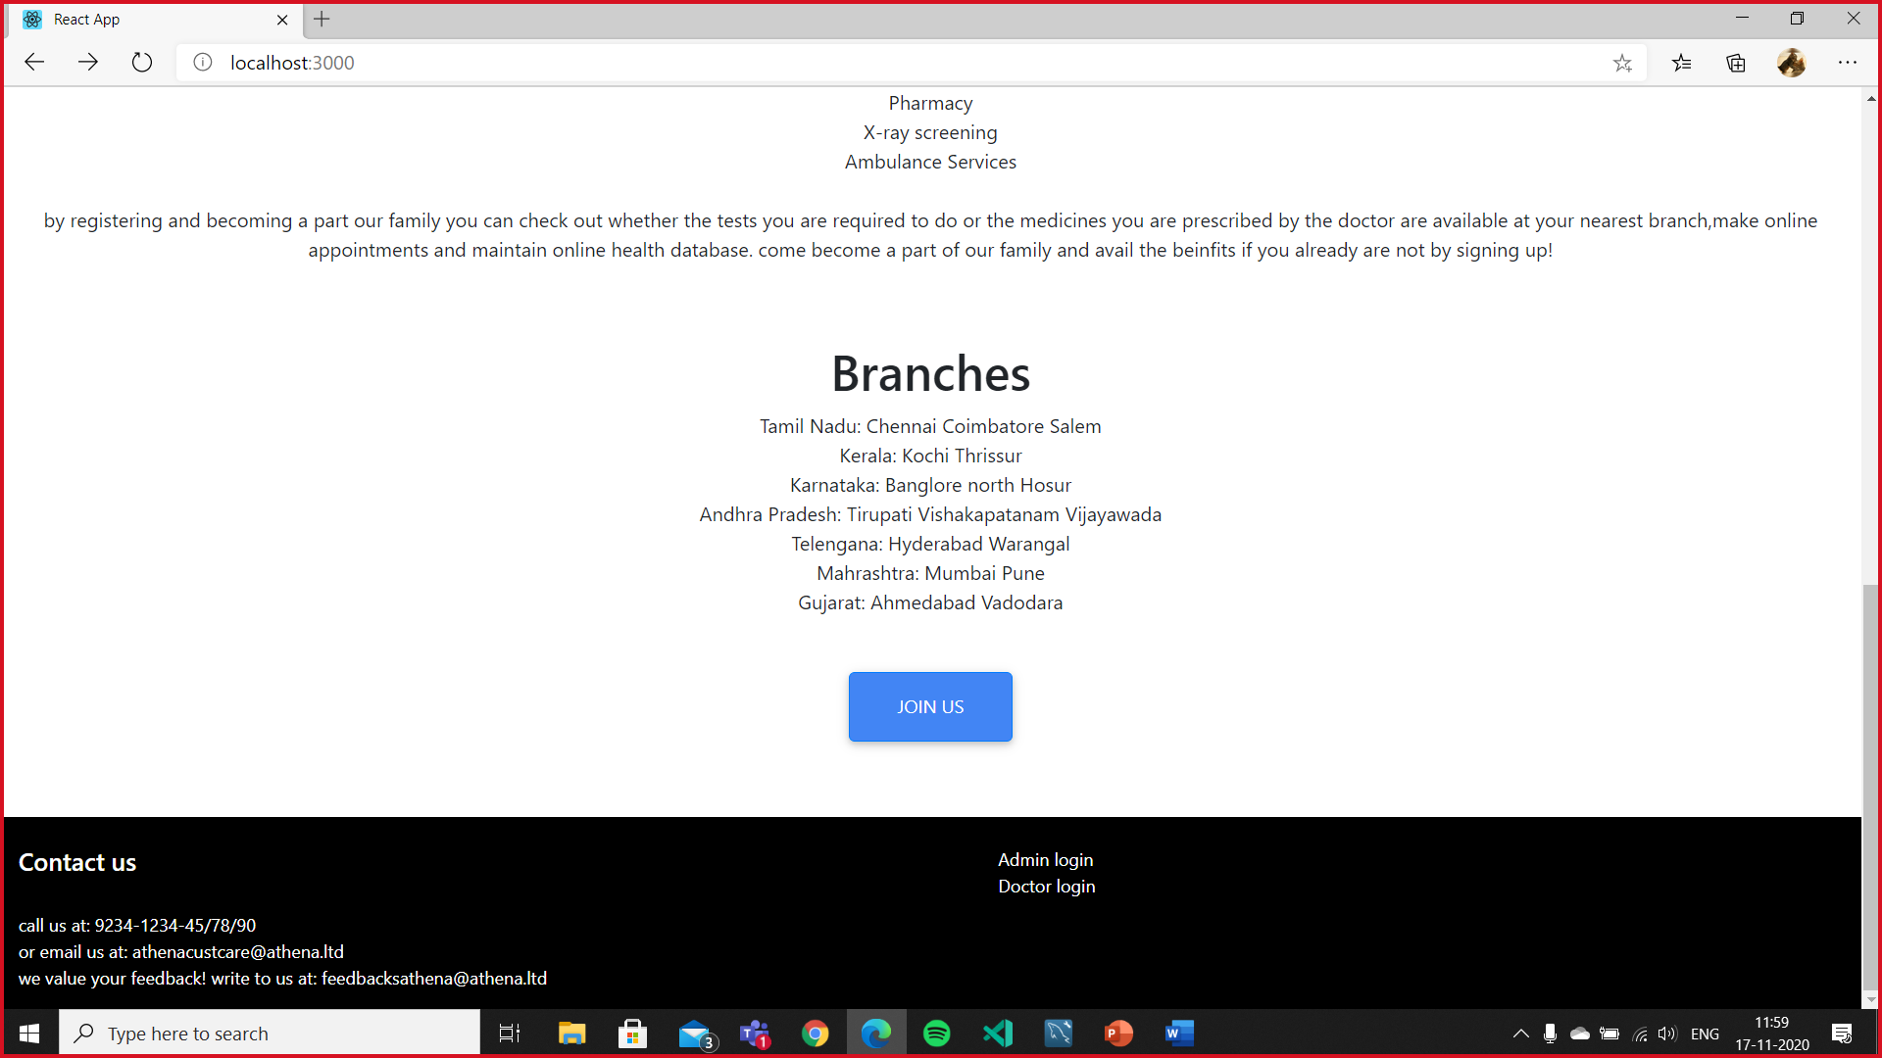

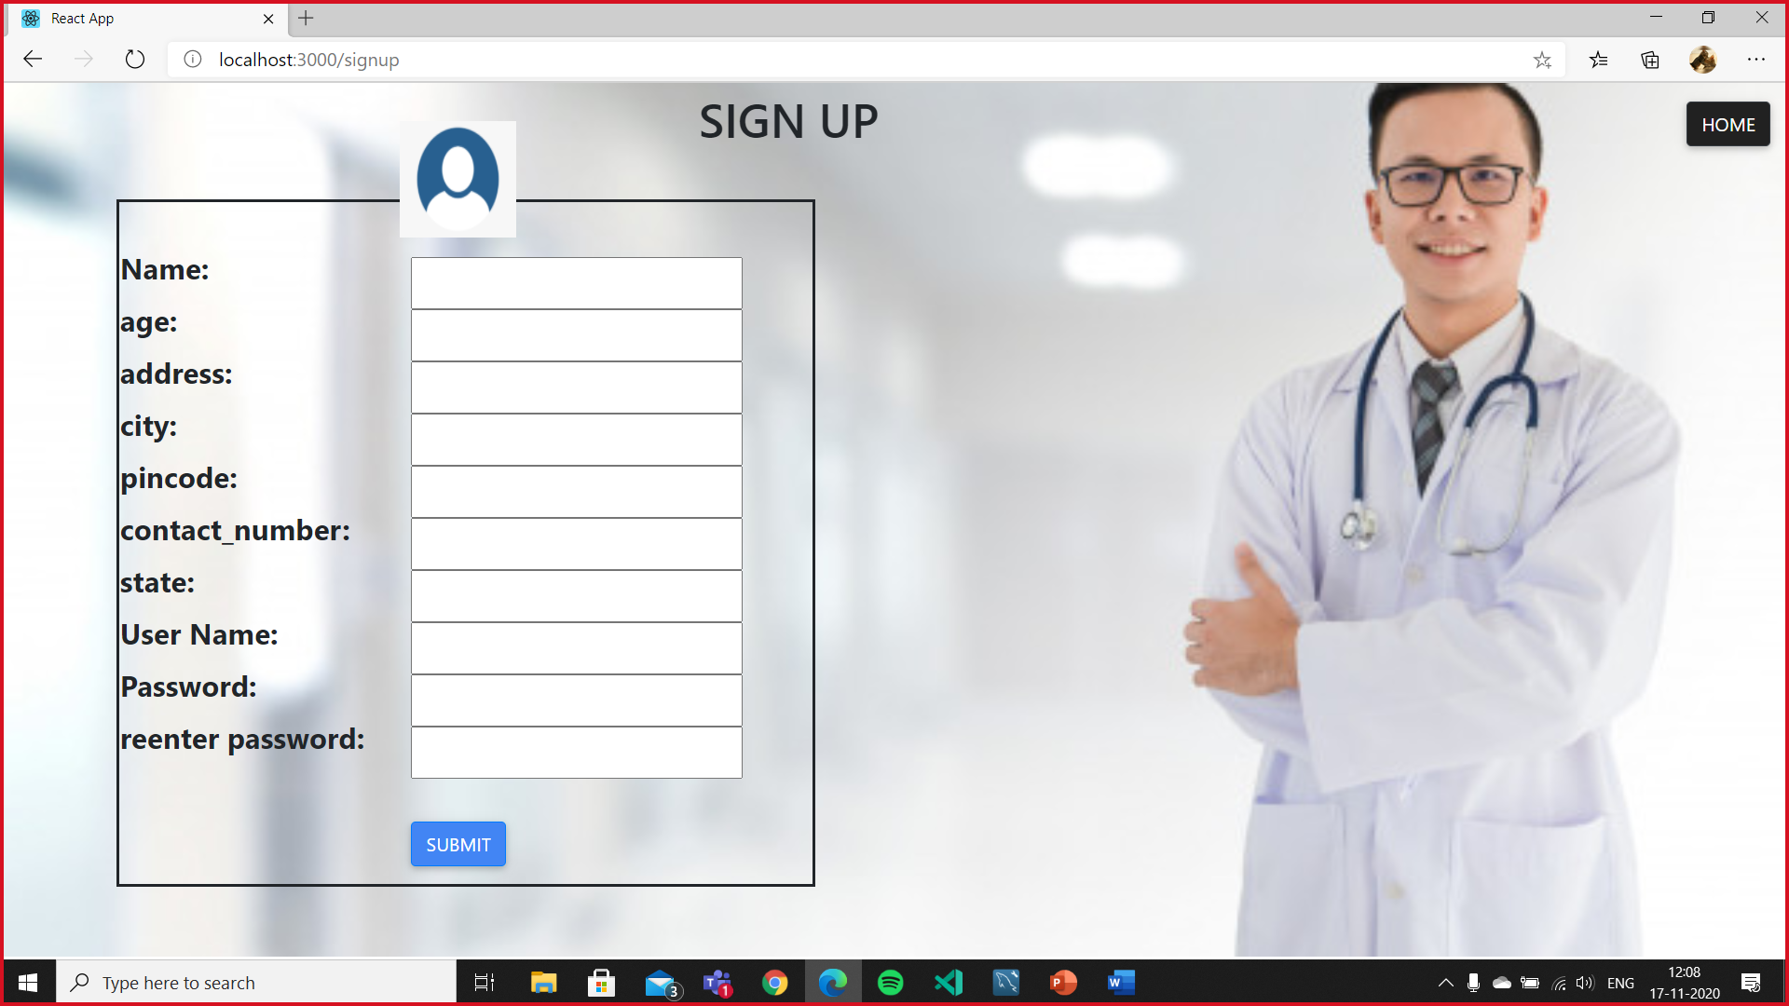

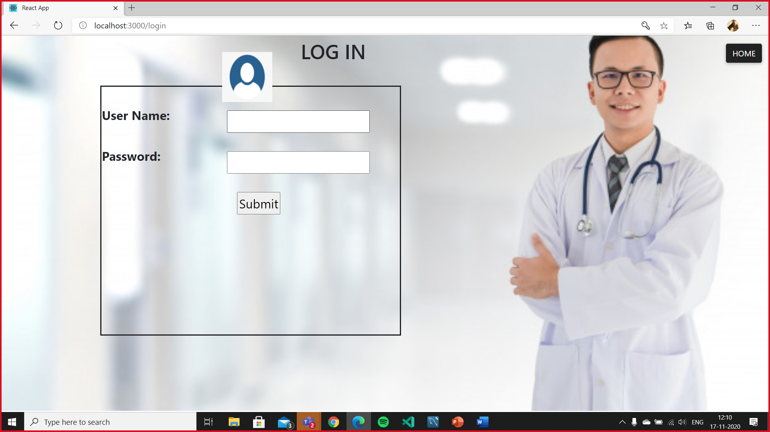

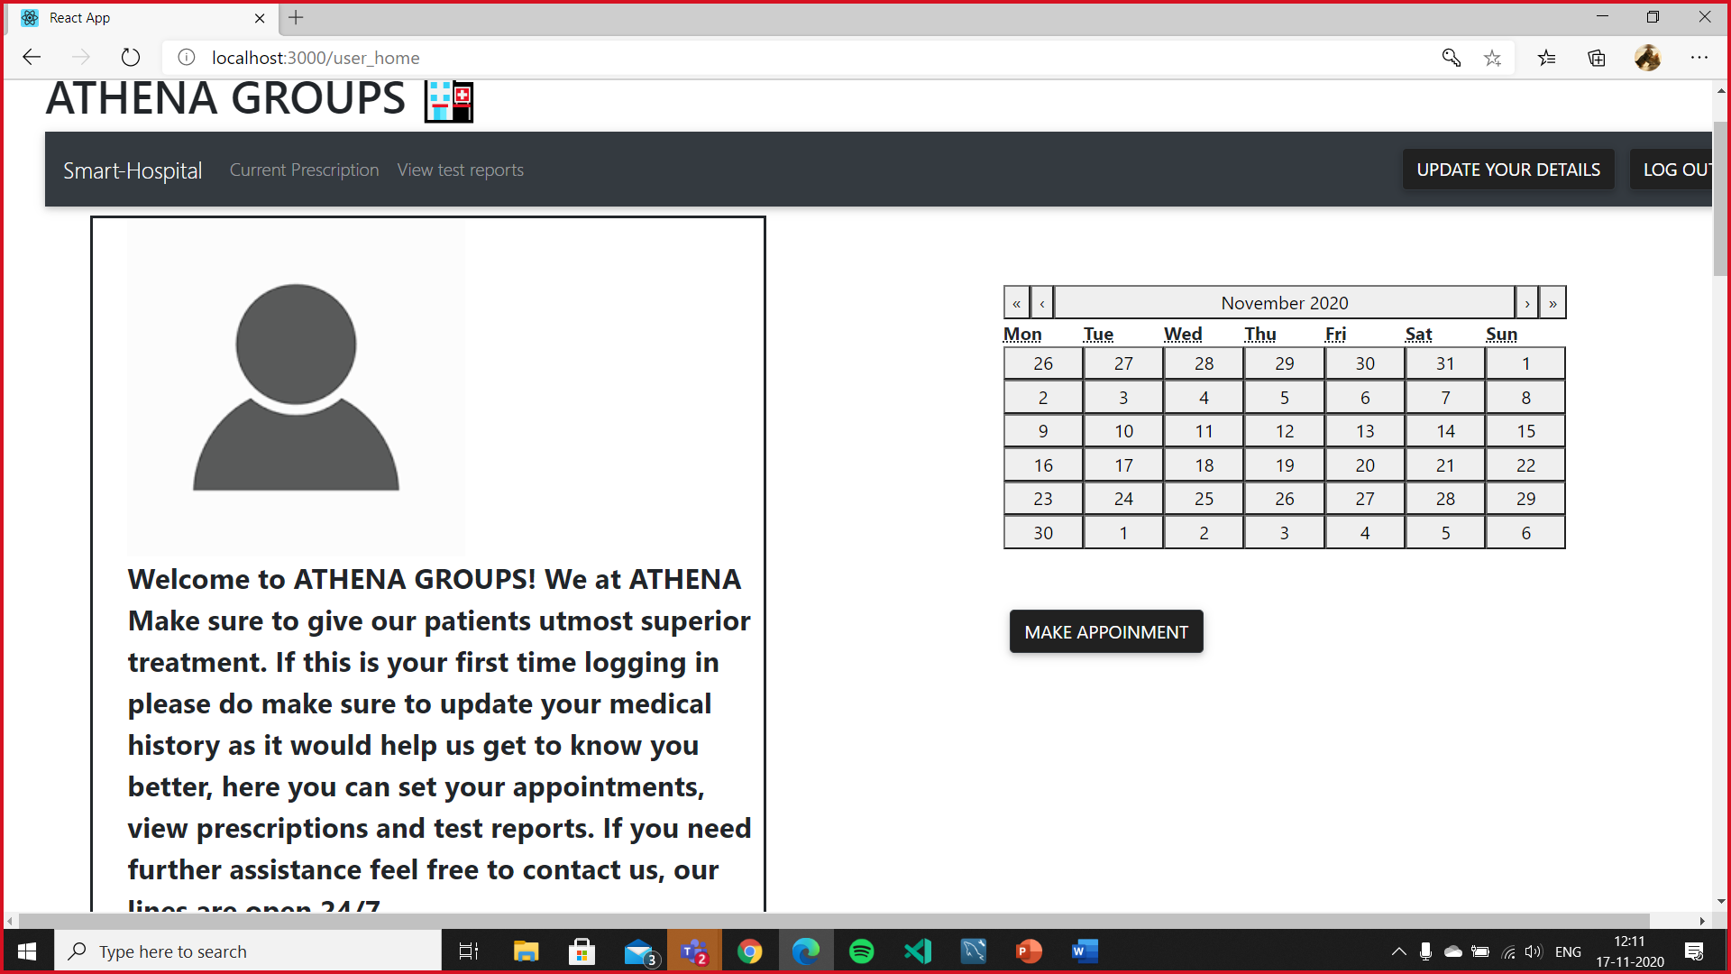

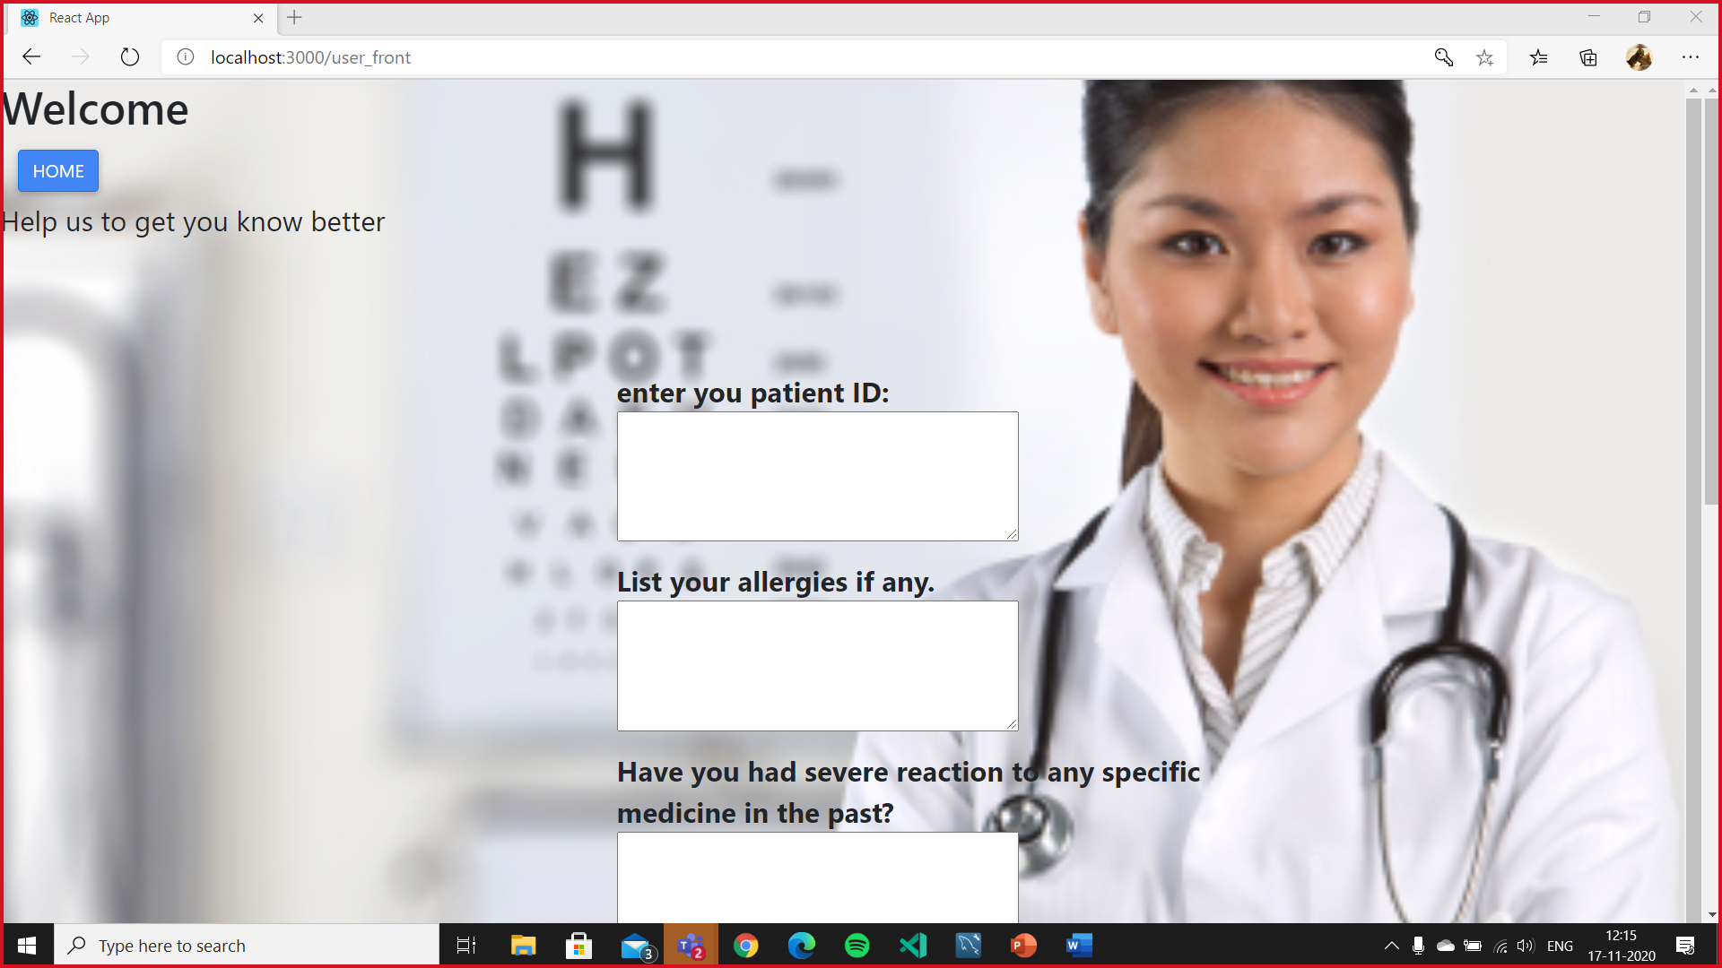

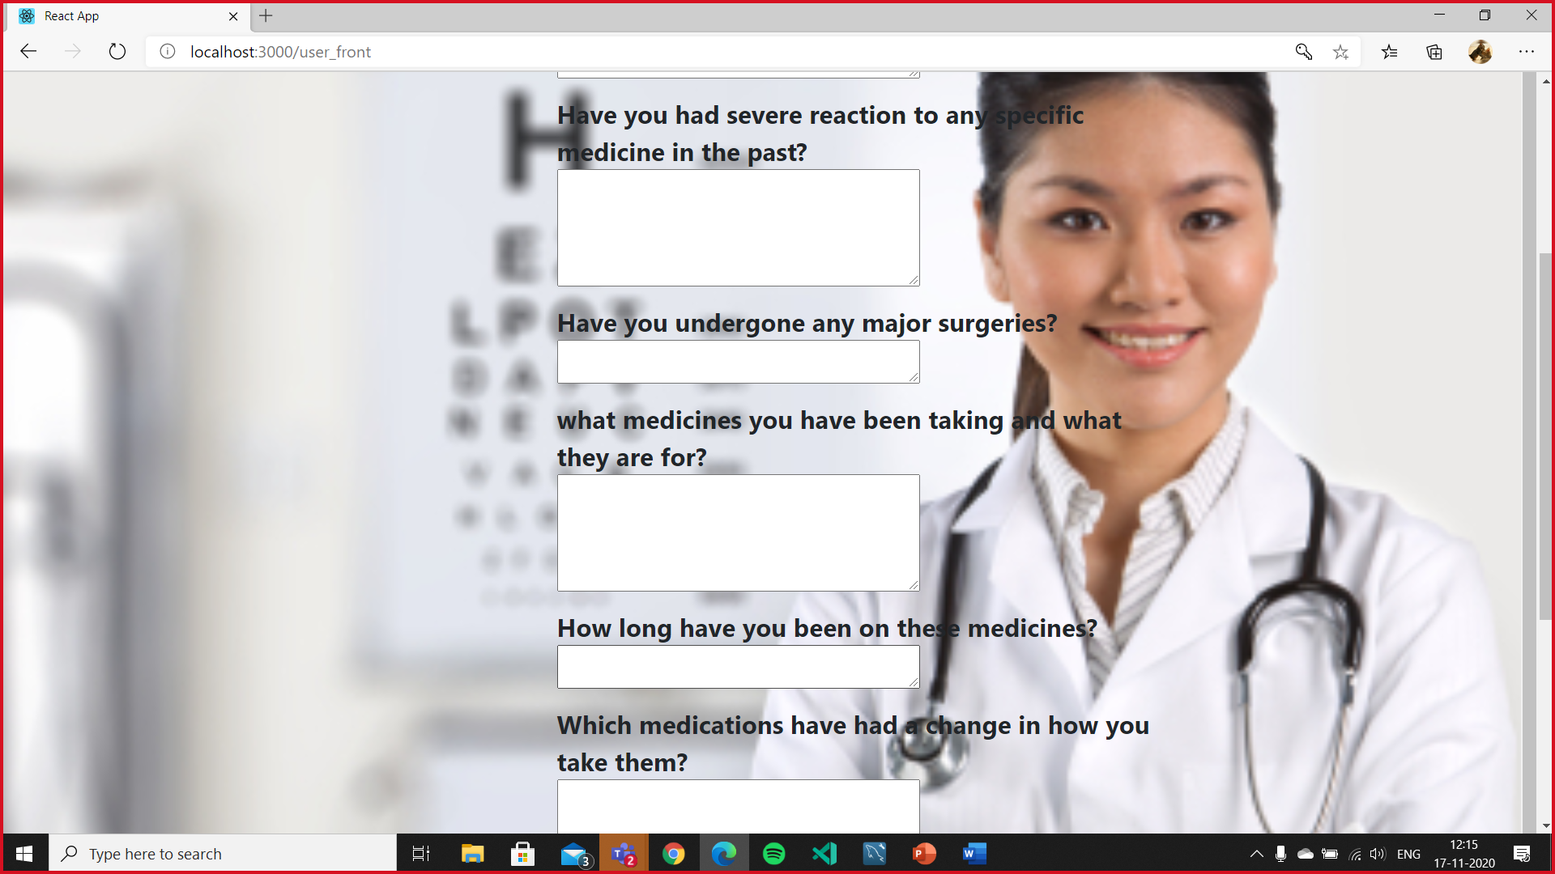

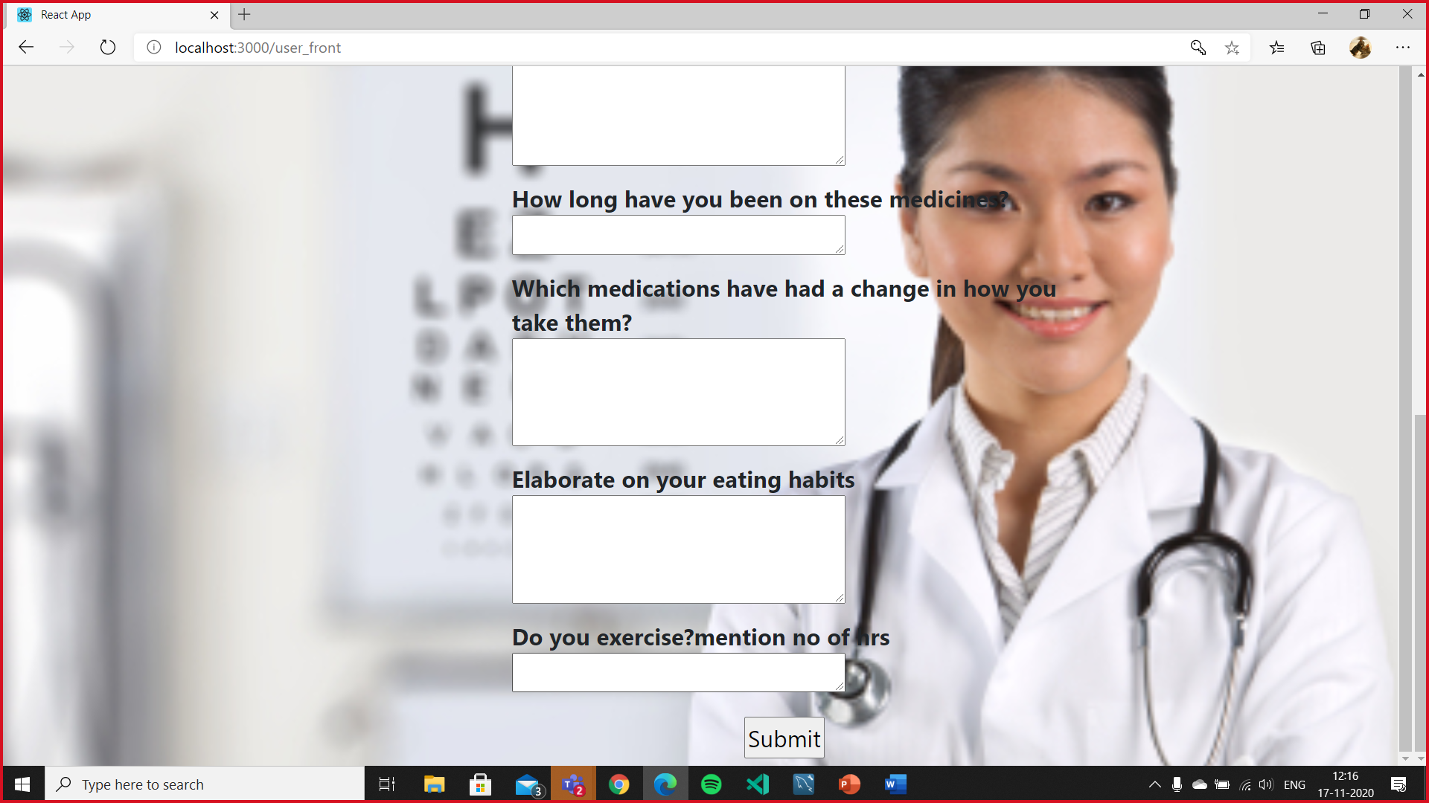

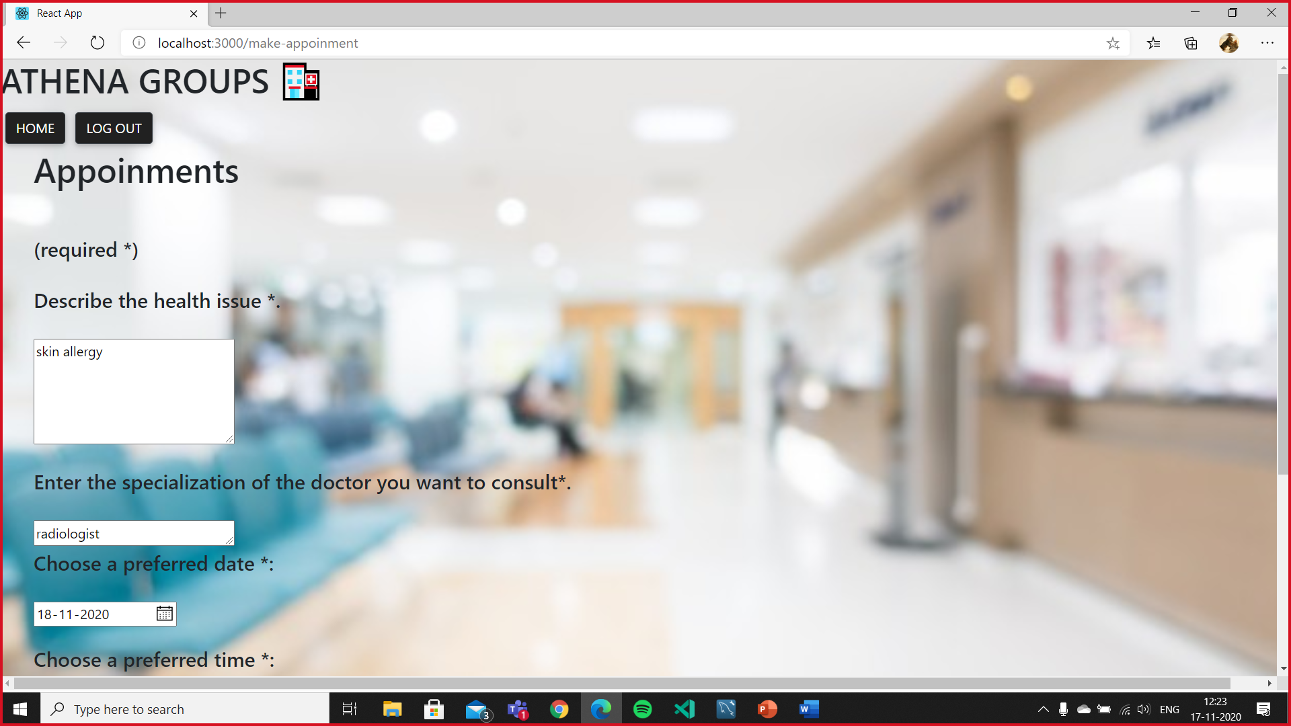

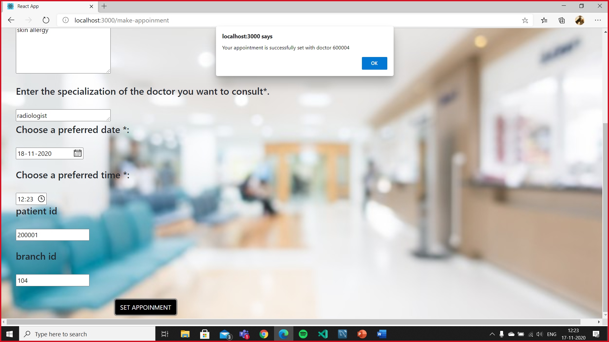

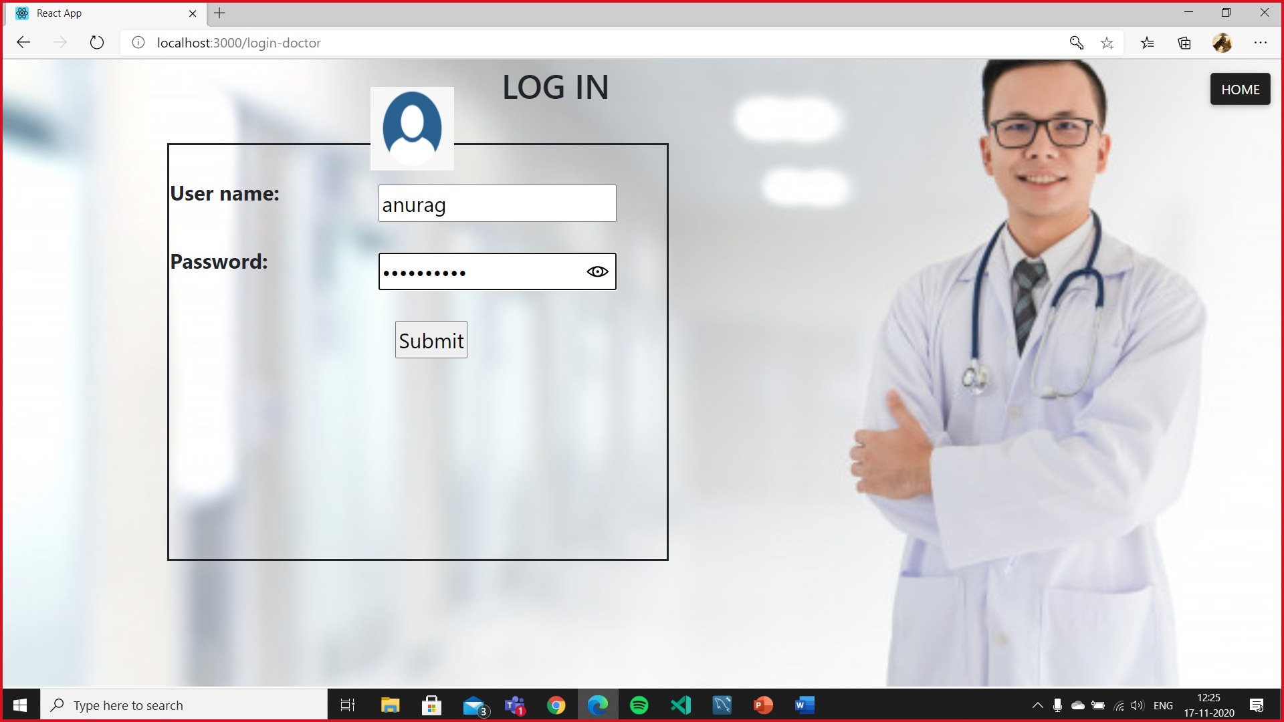

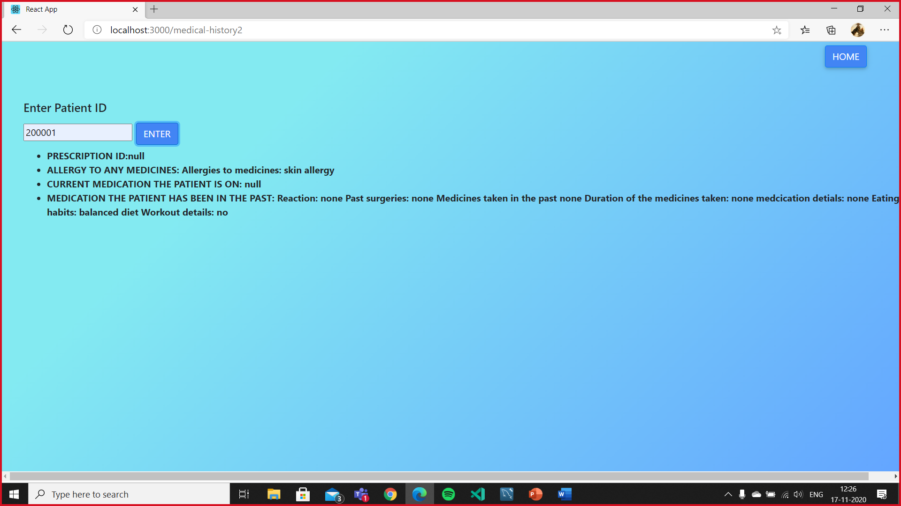

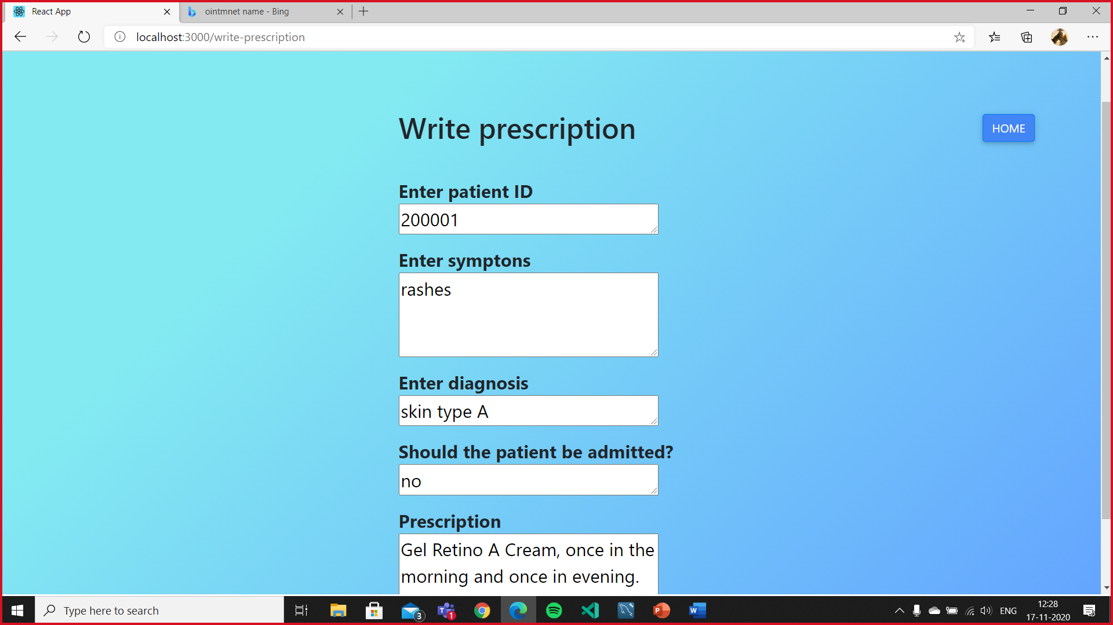

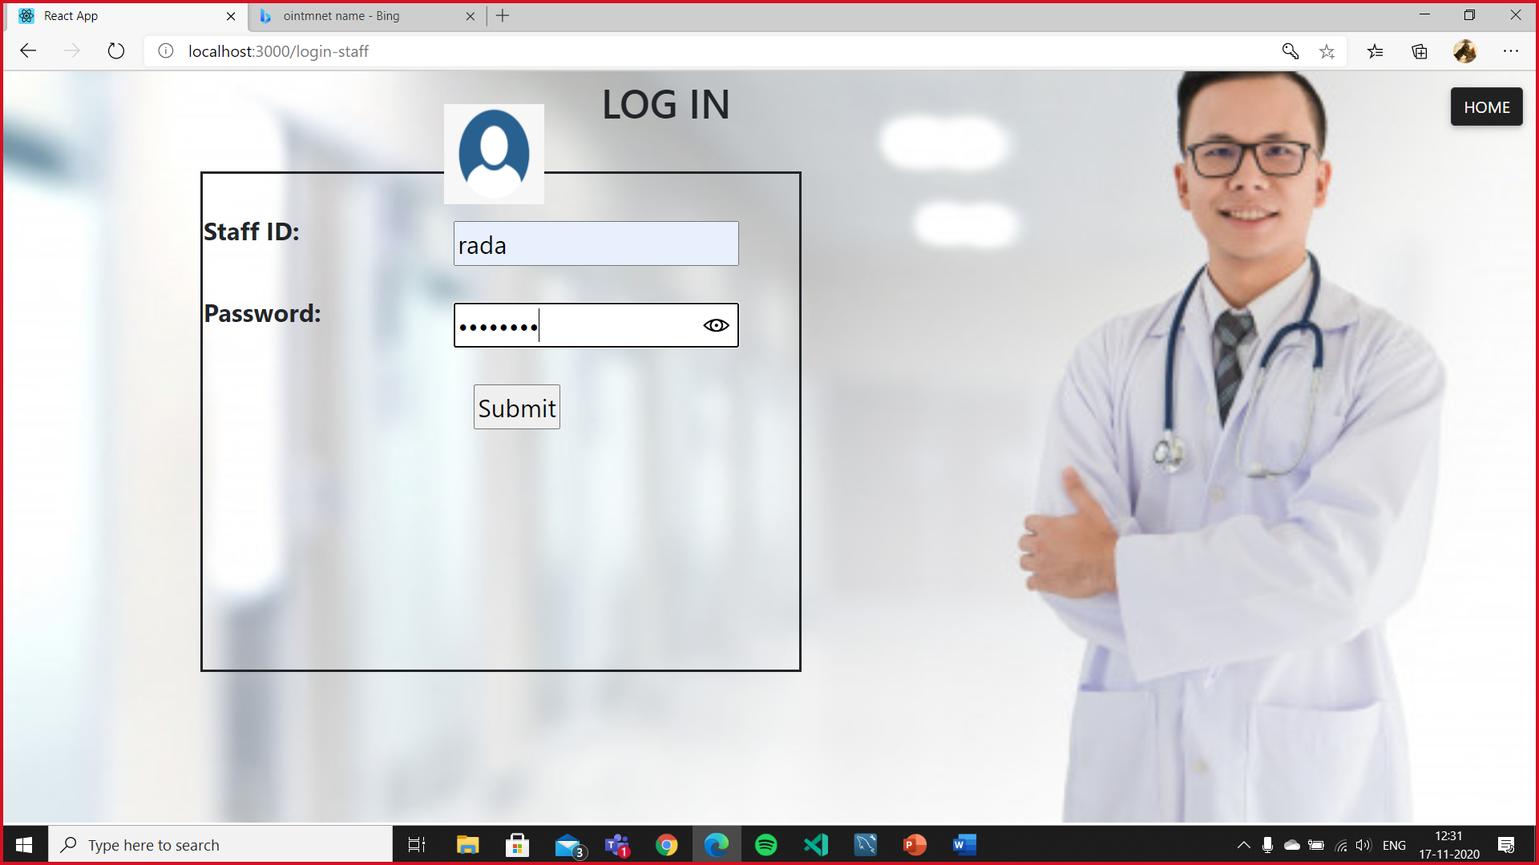

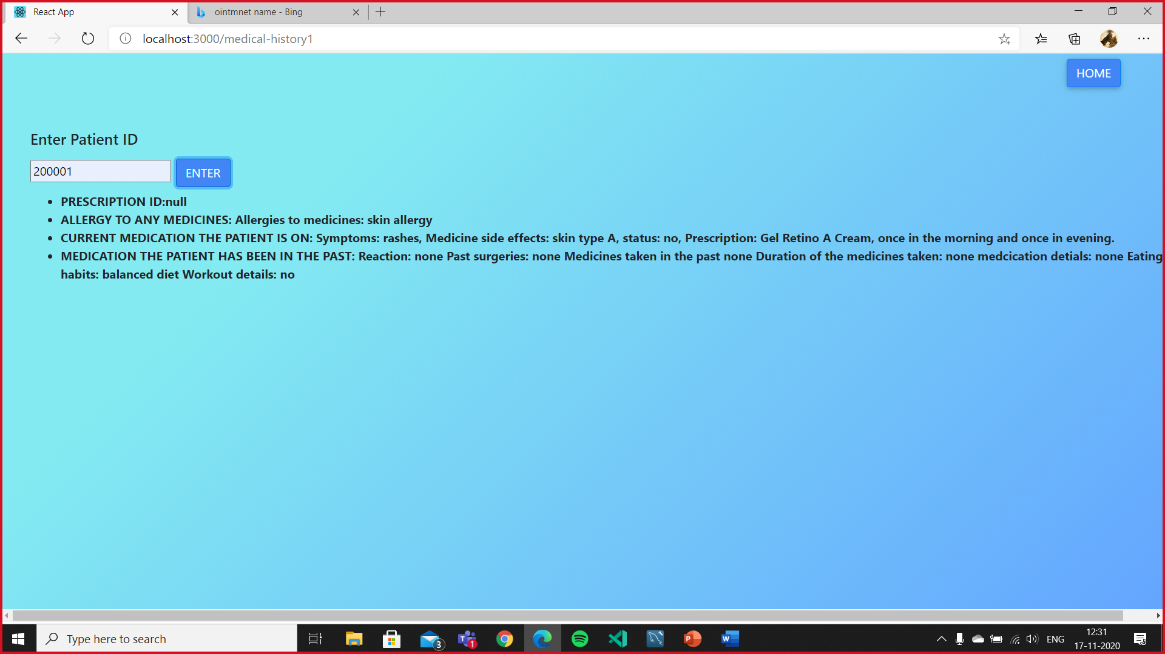

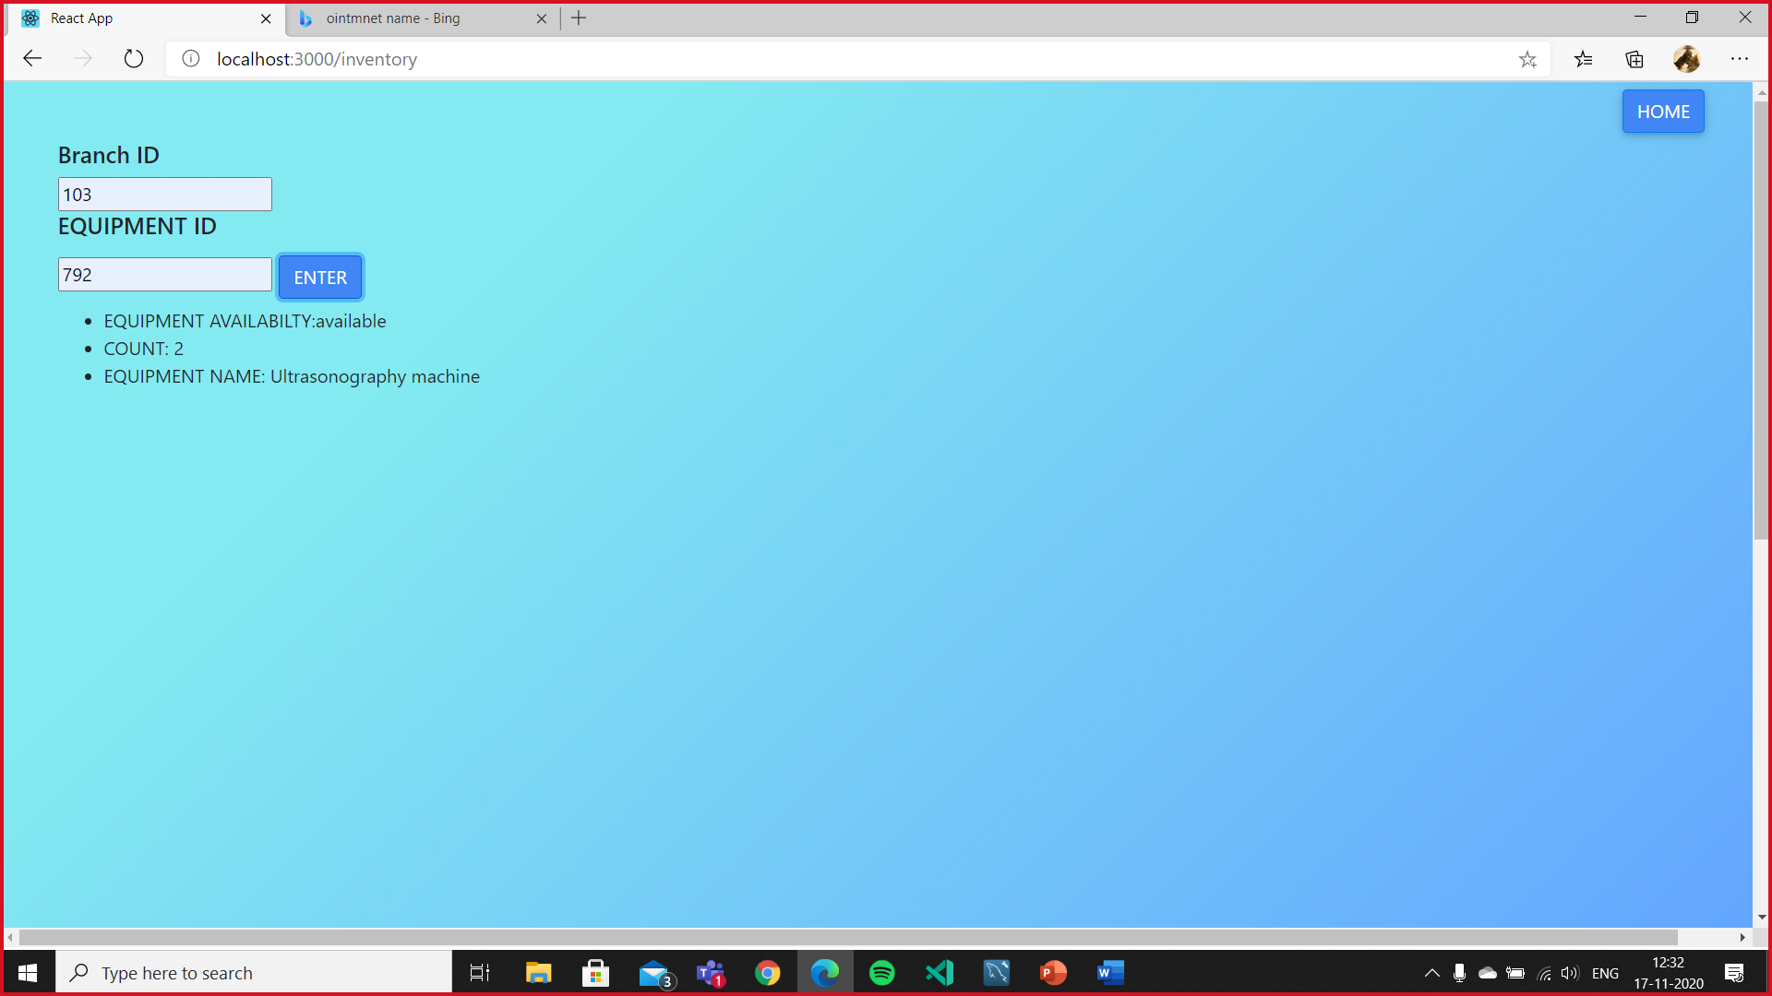

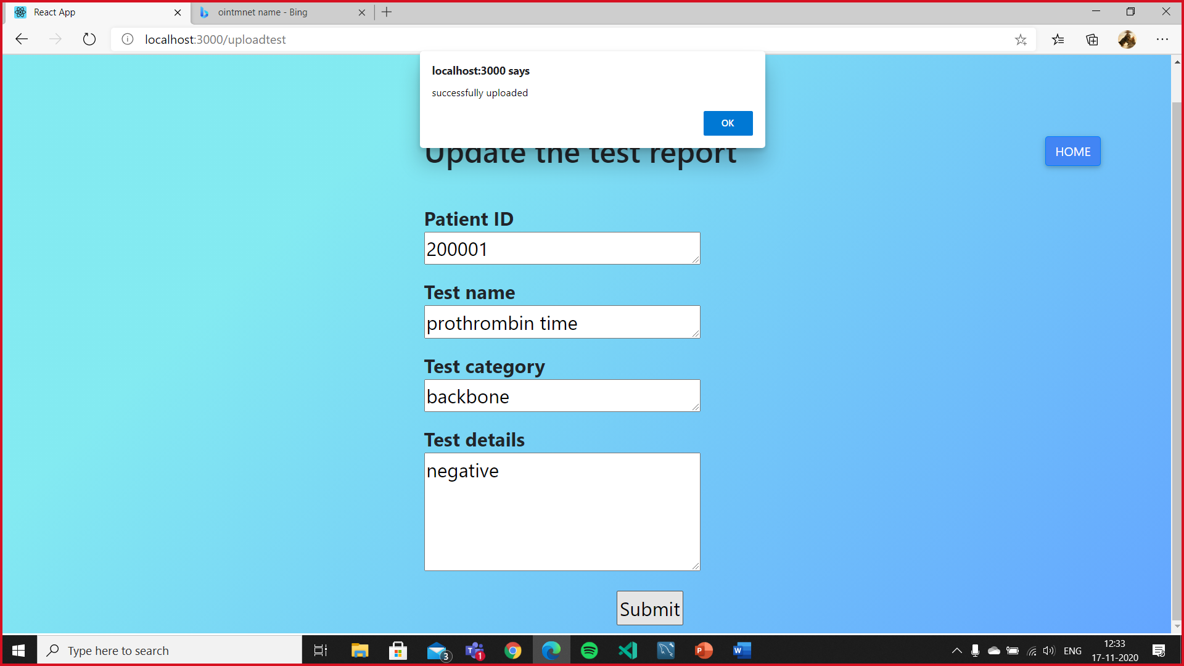

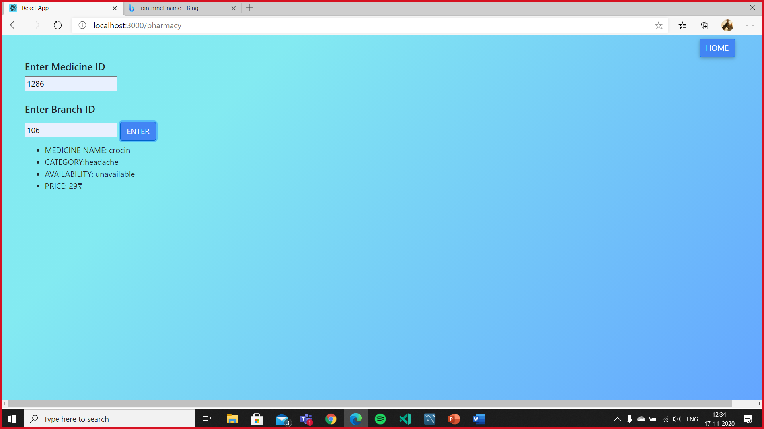

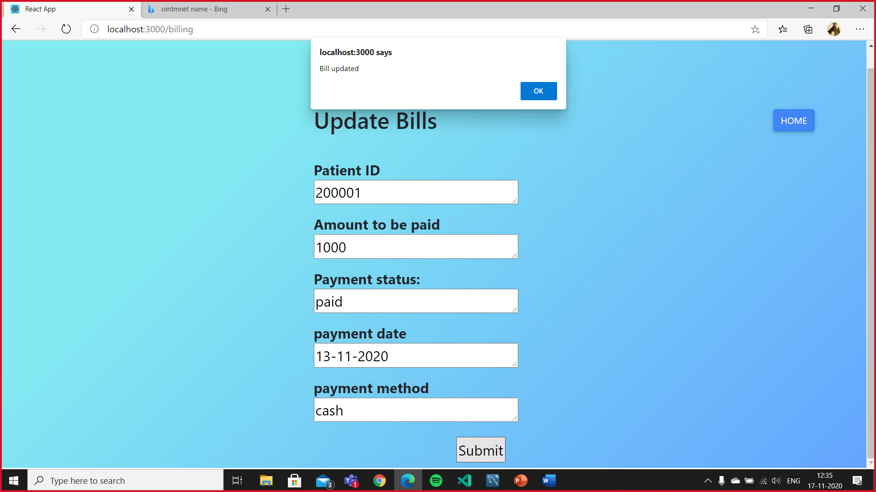

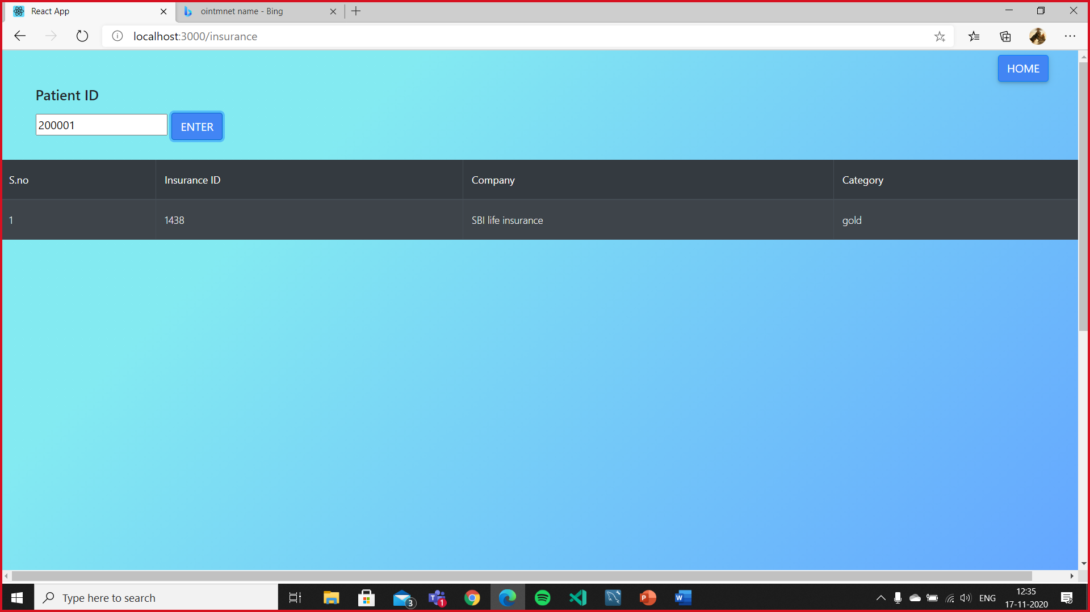

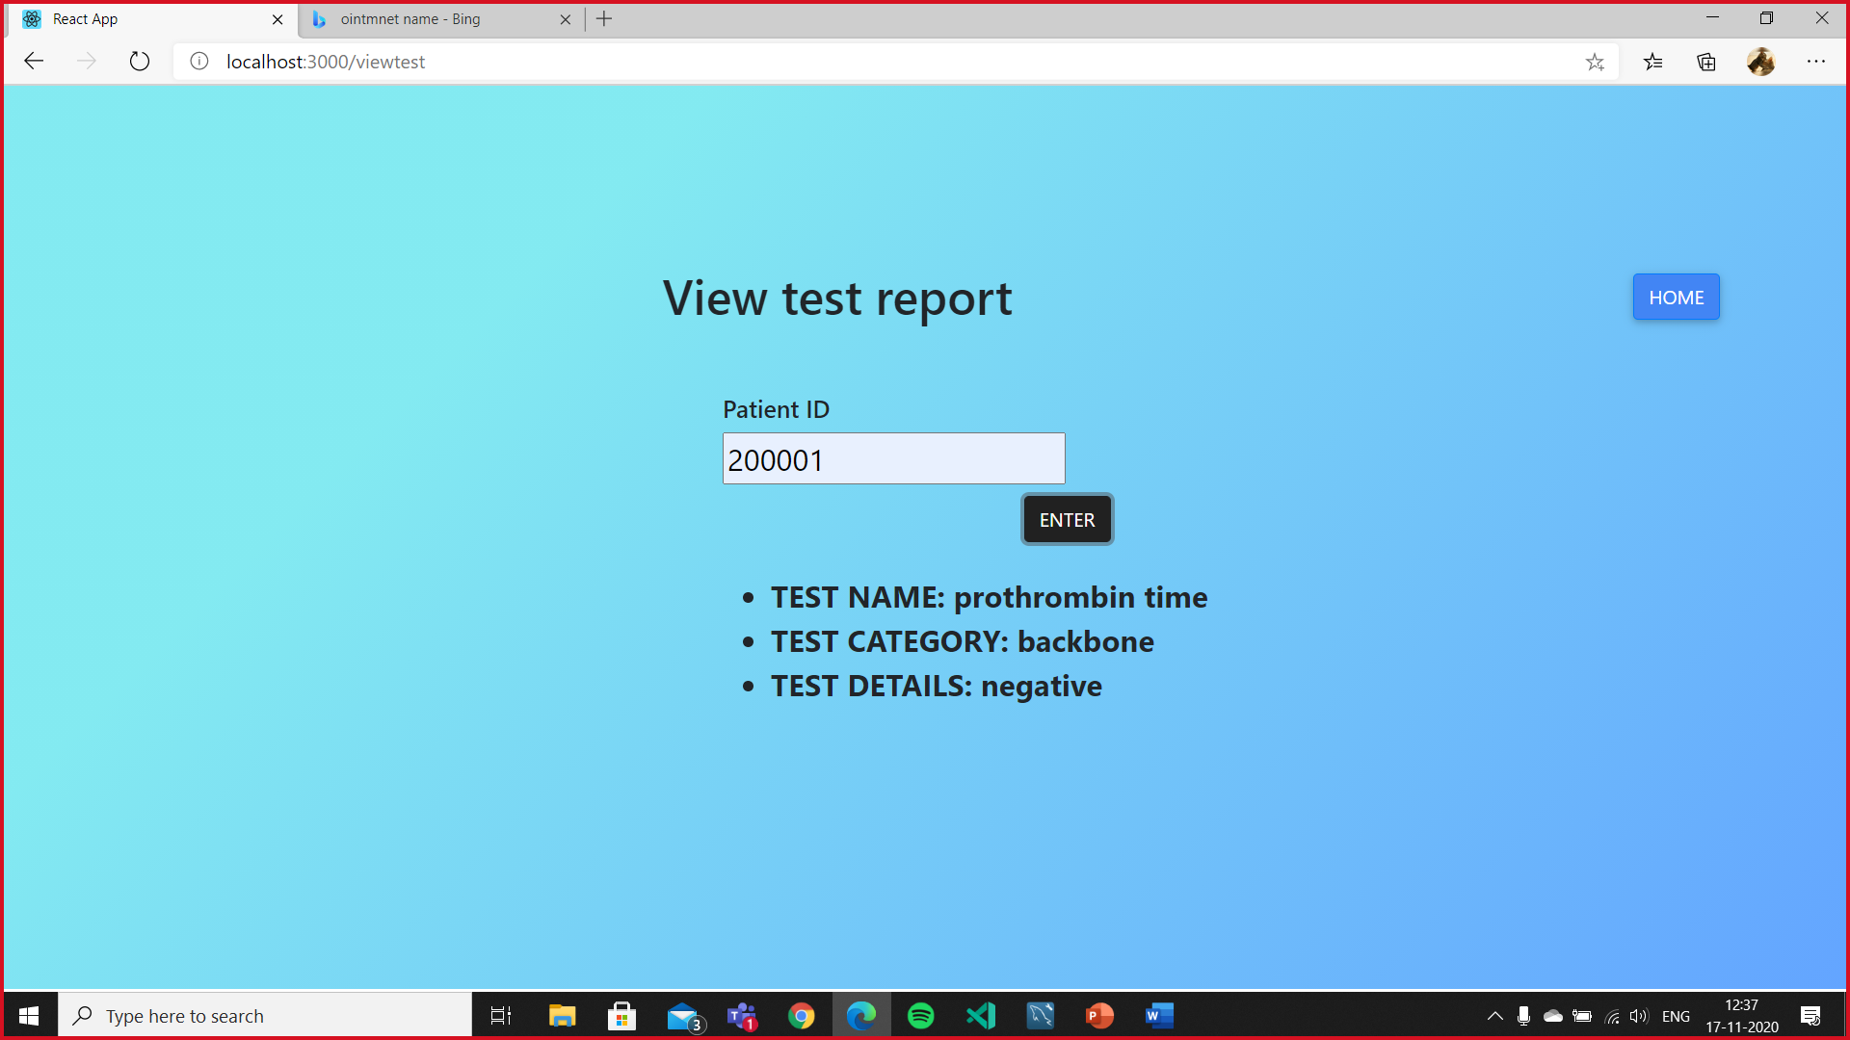

Database connectivity

Introduction to connectivity standard

We have made use of Node JS and MYSQL workbench to connect our front end to backend. We are making use of axios to send required values from front to backend  
and vice versa.

Data Base Connectivity:

const express = require('express');

const app = express();

const mysql = require('mysql');

const cors = require('cors');

const bodyParser = require('body-parser');

var router = express.Router()

var url = require('url');

var br_id;

var l_id=0;

var pid;

var pr_id1;

var pid2;

var ts_id1;

var pid3;

var desp;

const db = mysql.createPool({

    host:"localhost",

    user:"root",

    password:"12345",

    database:"hospital"

});

app.use(cors());

app.use(express.json());

app.use(bodyParser.urlencoded({extended:true}));

app.post("/api/insert",(req,res)=>{

    const name = req.body.name1;

    const address=req.body.address;

    const city=req.body.city;

    const pincode=req.body.pincode;

    const contact_number=req.body.cont_no;

    const state=req.body.state;

    const username=req.body.username;

    const password=req.body.pass;

    const renter_password=req.body.pass_chk;

    const age=req.body.age;

    if(password==renter_password)

    {

        const insert_login = "insert into login_details(l_usern,l_pass,l_category) values (?,?,'patient')";

    db.query(insert_login,[username,password],(err,result)=>{

        console.log(result);

    })

Sample code

Front end

App.js

import React, { Component } from 'react';

import { BrowserRouter, Route,Switch } from 'react-router-dom';

import home from './component/home';

import login from './component/login';

import submit_signup from './component/signup';

import userfront from './component/patient-history';

import userhome from './component/user_home';

import loginn from './component/login-p';

import makeappoinment from './component/make-appoinments';

import staff_front from './component/staff-front';

import loginnd from './component/login-doc';

import doc_front from './component/doc-front';

import MEDICAL from './component/medical_history';

import MEDICAL1 from './component/medical-history1';

import MEDICAL2 from './component/medical-history2';

import billing from './component/billing';

import pharmacy from './component/pharmacy';

import inventory from './component/inventory';

import insurance from './component/insurance';

import writePrescription from './component/write-prescription';

import uploadtest from './component/upload-test-report';

import viewtest from './component/viewtest';

import viewtest2 from './component/view_test2';

import currp from './component/curr';

class App extends Component {

  render() {

    return (

<BrowserRouter>

            <Switch>

             <Route path="/" component={home} exact/>

             <Route path="/login" component={login}/>

             <Route path="/signup" component={submit_signup}/>

             <Route path="/user_front" component={userfront}/>

             <Route path="/user_home" component={userhome}/>

             <Route path="/make-appoinment" component={makeappoinment}/>

             <Route path="/login-staff" component={loginn}/>

             <Route path="/staff-front" component={staff_front}/>

             <Route path="/login-doctor" component={loginnd}/>

             <Route path="/doc-front" component={doc_front}/>

             <Route path="/medical-history" component={MEDICAL}/>

             <Route path="/medical-history1" component={MEDICAL1}/>

             <Route path="/medical-history2" component={MEDICAL2}/>

             <Route path="/billing" component={billing}/>

             <Route path="/pharmacy" component={pharmacy}/>

             <Route path="/inventory" component={inventory}/>

             <Route path="/insurance" component={insurance}/>

             <Route path="/write-prescription" component={writePrescription}/>

             <Route path="/uploadtest" component={uploadtest}/>

             <Route path="/viewtest" component={viewtest}/>

             <Route path="/viewtest2" component={viewtest2}/>

             <Route path="/cprescription" component={currp}/>

           </Switch>

      </BrowserRouter>

    );

  }

}

export default App;

user login

import React from "react";

import './login.css';

import { Link } from 'react-router-dom';

import { Button } from "react-bootstrap";/*Nav, Navbar,*/

import ReactDOM from 'react-dom';

import axios from 'axios';

var element;

const login=()=>{

    return(

        <div className="Login">

        <div className='head1'><h1>LOG IN </h1></div>

          <div className='box1'>

          <img src="https://ga.berkeley.edu/wp-content/uploads/2015/08/146-1468479_my-profile-icon-blank-profile-picture-circle-hd.png" className="im"/>

          <form id="login-patient" onSubmit={(e)=>submit_login(e)}>

               <br></br>

                <label>

                  User Name:

                    <input type="text" name="uname" id="uname" className='box1inp'/>

                </label>

                <br></br>

                <label>

                  <br></br>

                  Password:

                    <input type="password" name="pwd" id="pwd"className='box1inp'/>

                </label>

                <br></br>

               <input type="submit" value="Submit" className='submit' />

                <br></br>

                <div id="data">

                </div>

            </form>

            </div>

            <br></br>

            <br></br>

            <Link to='/'><Button  variant="dark" className='but' >Home</Button></Link>

            </div>

    );

}

//<Link to ="/user_home"></Link>

function submit_login(e){

  e.preventDefault();

  let request =  {

      username:document.getElementById('uname').value,

      pass:document.getElementById('pwd').value,

  }

  axios.post('http://localhost:3001/api/login_chk',request)

  .then(resp=>{

    var details = resp.data;

    if(details=='SUCCESS..')

    {

      element = <p >{details}</p>;

      ReactDOM.render(element, document.getElementById('data'));

      window.location.replace('/user_home');

    }

    else

    {

      element = <p >{details}</p>

      ReactDOM.render(element, document.getElementById('data'));

    }

  })

  .catch(err=>{

    console.log(err);

  })

}

export default login;

user home

import React from 'react';//, { Component }

import { Nav, Navbar,Button } from "react-bootstrap";

import image from "./download.png";

import './user_home.css';

import Calendar from 'react-calendar';

//import { Document, Page } from 'react-pdf';

import { Link } from 'react-router-dom';

const userhome=()=>{

    return (

      <div className="boddy">

           <h1>ATHENA GROUPS <span>🏥</span>  </h1>

      <Navbar collapseOnSelect expand="lg" bg="dark" variant="dark">

      <Navbar.Brand href="#home">Smart-Hospital</Navbar.Brand>

      <Navbar.Toggle aria-controls="responsive-navbar-nav" />

      <Navbar.Collapse id="responsive-navbar-nav">

        <Nav className="mr-auto">

          <Nav.Link href="/cprescription">Current Prescription</Nav.Link>

          <Nav.Link href="/viewtest">View test reports</Nav.Link>

        </Nav>

        <Nav>

        <Link to='/user_front'><Button variant="dark" >Update your details</Button></Link>

 <Link to='/'><Button variant="dark" >Log out</Button></Link>

  </Nav>

      </Navbar.Collapse>

      </Navbar>

      <div className="image">

        <img src={image} alt="hello"></img>

          <p>

          Welcome to ATHENA GROUPS! We at ATHENA Make sure to give our patients utmost superior treatment. If this is your first time logging in please do make sure to

update your medical history as it would help us get to know you better, here you can set your appointments, view prescriptions and test reports.

If you need further assistance feel free to contact us, our lines are open 24/7.

          </p>

        </div>

        <div className="calender">

        <Calendar activeMonth={new Date()} />

        <br></br>

        <br></br>

        <Link to='/make-appoinment'><Button variant="dark" >Make appoinment</Button></Link>

      </div>

      </div>

    );

  }

export default userhome;

current prescription

import React from 'react';// ,{Component}

import "./inventory.css";

import { Button } from 'react-bootstrap';

import { Link } from 'react-router-dom';

import axios from 'axios';

import ReactDOM from 'react-dom';

var element;

//import {useEffect,useState} from 'react';

  const currp=()=>{

    return (

      <div className="thisisit">

      <div className="details">

        <Link to ="/user_home"><Button className="home">Home</Button></Link>

        <h1>View my prescription </h1>

        <form id="myForm" onSubmit={(e)=>submit_CP(e)}>

          <div className="start">

            <h5>Patient ID</h5>

            <input id="pid5"></input>

            <br></br>

            <Button type="submit" variant="dark" id="submit" className='box1inp'>Enter</Button>

            <br></br>

            <br></br>

            <div id="data"></div>

          </div>

        </form>

      </div>

      </div>

    );

  }

  function submit_CP(e){

    e.preventDefault();

    let request =  {

      pid6:document.getElementById('pid5').value,

    }

    axios.post('http://localhost:3001/med_his',request)

    .then(resp=>{

      console.log(resp);

      var details = resp.data;

      if(details.med_past)

      {

        element = <ul>

        <li>PRESCRIPTION ID:{details.pr_id}</li>

        <li>MEDICATION PRESCRIPBED FOR THE PATIENT: {details.med_current}</li>

        <li>MEDICATION THE PATIENT HAS BEEN IN THE PAST: {details.med_past}</li>

        </ul>

        ReactDOM.render(element, document.getElementById('data'));

      }

      else

      {

        alert('Please enter the patient ID corresponding to your account.');

      }

    })

    .catch(err=>{

      console.log(err);

    })

  }

export default currp;

view test

import React from 'react';// ,{Component}

import "./inventory.css";

import { Button } from 'react-bootstrap';

import { Link } from 'react-router-dom';

import axios from 'axios';

import ReactDOM from 'react-dom';

var element;

//import {useEffect,useState} from 'react';

  const viewtest=()=>{

    return (

      <div className="thisisit">

      <div className="details">

        <Link to ="/user_home"><Button className="home">Home</Button></Link>

        <h1>View test report</h1>

        <form id="myForm" onSubmit={(e)=>submit_view_test(e)}>

          <div className="start">

            <h5>Patient ID</h5>

            <input id="pid5"></input>

            <br></br>

            <Button type="submit" variant="dark" id="submit" className='box1inp'>Enter</Button>

            <br></br>

            <br></br>

            <div id="data"></div>

          </div>

        </form>

      </div>

      </div>

    );

  }

  function submit_view_test(e){

    e.preventDefault();

    let request =  {

      pid5:document.getElementById('pid5').value,

    }

    axios.post('http://localhost:3001/test_report',request)

    .then(resp=>{

      console.log(resp);

      var details = resp.data;

      console.log('aaa'+details.length)

      console.log('bbb'+details)

      if(details.test_name)

      {

        element = <ul>

        <li> TEST NAME: {details.test_name} </li>

        <li> TEST CATEGORY: {details.test_category}</li>

        <li>TEST DETAILS: {details.test_details}</li>

        </ul>

        ReactDOM.render(element, document.getElementById('data'));

      }

      else

      {

        alert('Please enter the patient ID corresponding to your account.');

      }

      //alert(resp.data);

    })

    .catch(err=>{

      console.log(err);

    })

  }

/*

  class RandomPlace extends Component {

    constructor(props) {

        super (props);

        this.state = {

            response: {},

        };

    }

    async componentDidMount() {

        const res = await axios.get('/test_report');

        this.setState({ response: res.data })

    }

    render() {

        return (

            <div>

                {this.state.response}

            </div>

        );

    }

}*/

//export {RandomPlace};

export default viewtest;

staff login

import React from "react";

import './login.css';

import { Link } from 'react-router-dom';

import { Button } from "react-bootstrap";/*Nav, Navbar,*/

import ReactDOM from 'react-dom';

import axios from 'axios';

const loginn=()=>{

    return(

        <div className="Login">

        <div className='head1'><h1>LOG IN </h1></div>

          <div className='box1'>

          <img src="https://ga.berkeley.edu/wp-content/uploads/2015/08/146-1468479_my-profile-icon-blank-profile-picture-circle-hd.png" className="im"/>

          <form id="login-patient" onSubmit={(e)=>submit_login(e)}>

               <br></br>

                <label>

                  Staff ID:

                    <input type="text" id="uname"name="name" className='box1inp'/>

                </label>

                <br></br>

                <label>

                  <br></br>

                  Password:

                    <input type="password" id="pwd" name="name" className='box1inp'/>

                </label>

                <br></br>

                <input type="submit" value="Submit" className='submit' />

                <br></br>

                <div id="data"></div>

            </form>

            </div>

            <Link to='/'><Button variant="dark" className='but' >Home</Button></Link>

            </div>

    );

}

function submit_login(e){

  e.preventDefault();

  let request =  {

      username:document.getElementById('uname').value,

      pass:document.getElementById('pwd').value,

  }

  axios.post('http://localhost:3001/s_login_chk',request)

  .then(resp=>{

    var details = resp.data;

    var element;

    if(details=='SUCCESS..')

    {

      element = <p>{details}</p>;

      ReactDOM.render(element, document.getElementById('data'));

      window.location.replace('/staff-front');

    }

    else

    {

      element = <p>{details}</p>

      ReactDOM.render(element, document.getElementById('data'));

    }

  })

  .catch(err=>{

    console.log(err);

  })

}

export default loginn;

write prescription

import React from 'react';

import { Button } from 'react-bootstrap';

import { Link } from 'react-router-dom';

import axios from 'axios';

  const writeprescription=()=>{

    return (

      <div className="thisisit">

      <div className="details">

        <Link to ="/doc-front"><Button className="home">Home</Button></Link>

        <h1>Write prescription</h1>

      <form id="myForm" onSubmit={(e)=>submit_d_prescription(e)}>

           <br></br>

           <label>

             Enter patient ID

             <br></br>

              <textarea id="pid1" name="message" rows="1" cols="30"></textarea>

                </label>

         <label>

             Enter symptons

             <br></br>

              <textarea id="symp" name="message" rows="3" cols="30"></textarea>

                </label>

            <br></br>

            <label>

            Enter diagnosis

            <br></br>

            <textarea  id="diag" name="message" rows="1" cols="30"></textarea>

            </label>

            <br></br>

            <label>

            Should the patient be admitted?

            <br></br>

            <textarea id="admt"  name="message" rows="1" cols="30"></textarea>

            </label>

            <br></br>

            <label>

            Prescription

            <br></br>

                <textarea id="pres"  name="message" rows="3" cols="30"></textarea>

            </label>

            <br></br>

           <input  type="submit" value="Submit" className='box1inp' />

            <br></br>

        </form>

        </div>

        </div>

    );

  }

  function submit_d_prescription(e){

    e.preventDefault();

    let request =  {

        pid1:document.getElementById('pid1').value,

        symp:document.getElementById('symp').value,

        diagnosis:document.getElementById('diag').value,

        admt:document.getElementById('admt').value,

        pres:document.getElementById('pres').value

    }

    axios.post('http://localhost:3001/med_current',request)

    .then(resp=>{

      console.log('resp.details'+resp.details)

      if(resp.details.length>0)

      {

        alert('Successfull issued prescription');

        console.log(resp.data.message)

      }

      else

      {

        alert('enter valid details');

      }

    })

    .catch(err=>{

      console.log(err);

    })

  }

export default writeprescription;

billing

import React from "react";

import { Button } from "react-bootstrap";//,Table

import { Link } from 'react-router-dom';

import axios from 'axios';

    const billing=()=>{

      return (

        <div className="thisisit">

        <div className="details">

          <Link to ="/staff-front"><Button className="home">Home</Button></Link>

          <h1>Update Bills</h1>

          <form id="myForm" onSubmit={(e)=>submit_pay_details(e)}>

             <br></br>

           <label>

               Patient ID

               <br></br>

                <textarea id="pid3" name="message" rows="1" cols="30"></textarea>

                  </label>

              <br></br>

              <label>

              Amount to be paid

              <br></br>

              <textarea id="pay_amt" name="message" rows="1" cols="30"></textarea>

              </label>

              <br></br>

              <label>

              Payment status:

              <br></br>

              <textarea id="pay_status" name="message" rows="1" cols="30"></textarea>

              </label>

              <br></br>

              <label>

              payment date

              <br></br>

                  <textarea id="pay_date" name="message" rows="1" cols="30"></textarea>

              </label>

              <br></br>

              <label>

              payment method

              <br></br>

                  <textarea id="pay_method" name="message" rows="1" cols="30"></textarea>

              </label>

              <br></br>

             <input type="submit" value="Submit" className='box1inp' />

              <br></br>

          </form>

          </div>

          </div>

      );

    }

    function submit_pay_details(e){

      e.preventDefault();

      let request =  {

          pid3:document.getElementById('pid3').value,

          pay_amt:document.getElementById('pay_amt').value,

          pay_status:document.getElementById('pay_status').value,

          pay_date:document.getElementById('pay_date').value,

          pay_method:document.getElementById('pay_method').value

      }

      axios.post('http://localhost:3001/pay_det',request)

      .then(resp=>{

        if(resp)

        {

          alert('Bill updated');

          console.log(resp.data.message)

        }

      })

      .catch(err=>{

        console.log(err);

      })

    }

export default billing;

ocor front

import React from "react";

import './doc-front.css';

import { Link } from 'react-router-dom';

import { Nav, Navbar,Button} from "react-bootstrap";

import Calendar from 'react-calendar';

import image from "./download.png";

const doc_front=()=>{

    return(

        <div>

        <Navbar collapseOnSelect expand="lg" bg="dark" variant="dark">

<Navbar.Brand href="#home">Smart-Hospital</Navbar.Brand>

<Navbar.Toggle aria-controls="responsive-navbar-nav" />

<Navbar.Collapse id="responsive-navbar-nav">

  <Nav className="mr-auto">

    <Nav.Link href="/medical-history2">View patient details</Nav.Link>

    <Nav.Link href="/write-prescription">Write prescription</Nav.Link>

    <Nav.Link href="/viewtest2">View test reports</Nav.Link>

  </Nav>

  <Nav>

 <Link to='/'><Button variant="dark" >Log out</Button></Link>

  </Nav>

</Navbar.Collapse>

</Navbar>

  <div className="image">

      <img src={image} alt="hello"></img>

        <p ><b> “The life so short, the craft so long to learn.”

                                        ― Hippocrates</b>

        </p>

        </div>

        <div className="calender">

        <Calendar activeMonth={new Date()} />

        <br></br>

        <br></br>

      </div>

</div>

    )

}

export default doc_front;

patient history

import React from 'react';

import './user_front.css';

import axios from 'axios';

import { Link } from 'react-router-dom';

import { Button } from 'react-bootstrap';

  const userfront=()=>{

    return (

      <div className="overall">

      <div className="heading"><h1>Welcome</h1>

      <Link to ="/user_home"><Button className="home1">Home</Button></Link>

      <p>Help us to get you know better </p>

      </div>

      <div className="details">

      <form id="myForm" onSubmit={(e)=>submit_p_medhistory(e)}>

           <label>

              enter you patient ID:

              <textarea id="P_ID"name="message" rows="3" cols="30"></textarea>

                </label>

            <br></br>

            <label></label>

         <label>

              List your allergies if any.

              <textarea id="allergy"name="message" rows="3" cols="30"></textarea>

                </label>

            <br></br>

            <label>

            Have you had severe reaction to any specific medicine in the past?

            <textarea id="reaction" name="message" rows="3" cols="30"></textarea>

            </label>

            <br></br>

            <label>

            Have you undergone any major surgeries?

            <textarea id="surgery" name="message" rows="1" cols="30"></textarea>

            </label>

            <br></br>

            <label>

            what medicines you have been taking and what they are for?

            <br></br>

                <textarea id="medicine" name="message" rows="3" cols="30"></textarea>

            </label>

            <br></br>

            <label>

            How long have you been on these medicines?

            <br></br>

            <textarea id="duration" name="message" rows="1" cols="30"></textarea>

            </label>

            <br></br>

            <label>

            Which medications have had a change in how you take them?

            <br></br>

            <textarea id="med_det" name="message" rows="3" cols="30"></textarea>

            </label>

            <br></br>

            <label>

            Elaborate on your eating habits

            <br></br>

            <textarea id="eat" name="message" rows="3" cols="30"></textarea>

            </label>

            <br></br>

            <label>

            Do you exercise?mention no of hrs

            <br></br>

            <textarea id="workout" name="message" rows="1" cols="30"></textarea>

            </label>

            <br></br>

           <input type="submit" value="Submit" className='box1inp' />

            <br></br>

        </form>

        </div>

      </div>

    );

  }

  function submit_p_medhistory(e){

    e.preventDefault();

    let request =  {

        pid:document.getElementById('P_ID').value,

        allergy:document.getElementById('allergy').value,

        reaction:document.getElementById('reaction').value,

        surgery:document.getElementById('surgery').value,

        medicine:document.getElementById('medicine').value,

        duration:document.getElementById('duration').value,

        med_det:document.getElementById('med_det').value,

        eat:document.getElementById('eat').value,

        workout:document.getElementById('workout').value,

    }

    axios.post('http://localhost:3001/insert_p_med_his',request)

    .then(resp=>{

      console.log(resp)

      alert('Successfully entered medical history');

    })

    .catch(err=>{

      console.log(err);

    })

  }

export default userfront;

pharmacy

import React from "react";

import { Button } from "react-bootstrap";

import { Link } from 'react-router-dom';

import ReactDOM from 'react-dom';

import axios from 'axios';

var element;

const pharmacy=()=>{

    return(

        <div className="thisisit">

           <Link to ="/staff-front"><Button className="homee">Home</Button></Link>

        <div className="start">

        <form id="myForm" onSubmit={(e)=>submit_pharm(e)}>

            <h5>Enter Medicine ID</h5>

            <input id='med_id'></input>

            <br></br>

            <br></br>

            <h5>Enter Branch ID</h5>

            <input id="br_id"></input>

            <Button type='submit'>Enter</Button>

            <div id="data"></div>

            </form>

            <br></br>

            <br></br>

            </div></div>

    )}

    function submit_pharm(e){

      e.preventDefault();

      let request =  {

        br_id:document.getElementById('br_id').value,

        med_id:document.getElementById('med_id').value,

      }

      axios.post('http://localhost:3001/pharm',request)

      .then(resp=>{

        console.log(resp);

        var details = resp.data;

        /*

         med_allergy:[med_allergy],

                      med_current:[med_current],

                      med_past:[med_past],

                      pr_id:[pr_id]

        */

        element = <ul>

        <li>MEDICINE NAME: {details.med_name}</li>

        <li> CATEGORY:{details.med_category} </li>

        <li>AVAILABILITY: {details.med_availability}</li>

        <li>PRICE: {details.med_price}₹</li>

        </ul>

        ReactDOM.render(element, document.getElementById('data'));

        //alert(resp.data);

      })

      .catch(err=>{

        console.log(err);

      })

    }

export default pharmacy;

staff front

import React from "react";

import { Link } from 'react-router-dom';

import { Nav, Navbar,Button } from "react-bootstrap";

import Calendar from 'react-calendar';

import image from "./download.png";

const staff_front=()=>{

    return(

        <div>

        <Navbar collapseOnSelect expand="lg" bg="dark" variant="dark">

<Navbar.Brand href="#home">Smart-Hospital</Navbar.Brand>

<Navbar.Toggle aria-controls="responsive-navbar-nav" />

<Navbar.Collapse id="responsive-navbar-nav">

  <Nav className="mr-auto">

   <Nav.Link href="/medical-history1">View medical history</Nav.Link>

    <Nav.Link href="/inventory">Check Inventory</Nav.Link>

    <Nav.Link href="/pharmacy">Pharmacy</Nav.Link>

    <Nav.Link href="/billing">Billing</Nav.Link>

    <Nav.Link href="/insurance">Check insurance</Nav.Link>

    <Nav.Link href="/uploadtest">Upload test reports</Nav.Link>

  </Nav>

  <Nav>

 <Link to='/'><Button variant="dark" >Log out</Button></Link>

  </Nav>

</Navbar.Collapse>

</Navbar>

      <div className="image">

      <img src={image} alt="hello"></img>

        <p><b>“The life so short, the craft so long to learn.”

                                              ― Hippocrates</b>

        </p>

      </div>

      <div className="calender">

      <Calendar activeMonth={new Date()} />

      <br></br>

      <br></br>

    </div>

    </div>

    )

}

export default staff_front;

upload test report

import React from 'react';

import "./upload-test-report.css";

import { Button } from 'react-bootstrap';

import { Link } from 'react-router-dom';

import axios from 'axios';

  const uploadtest=()=>{

    return (

      <div className="thisisit">

      <div className="details">

        <Link to ="/staff-front"><Button className="home">Home</Button></Link>

        <h1>Update the test report</h1>

        <form id="myForm" onSubmit={(e)=>submit_test_report(e)}>

           <br></br>

         <label>

             Patient ID

             <br></br>

              <textarea id="pid2" name="message" rows="1" cols="30"></textarea>

                </label>

            <br></br>

            <label>

            Test name

            <br></br>

            <textarea id="tst_name" name="message" rows="1" cols="30"></textarea>

            </label>

            <br></br>

            <label>

            Test category

            <br></br>

            <textarea id="tst_category" name="message" rows="1" cols="30"></textarea>

            </label>

            <br></br>

            <label>

            Test details

            <br></br>

                <textarea id="tst_det" name="message" rows="4" cols="30"></textarea>

            </label>

            <br></br>

           <input type="submit" value="Submit" className='box1inp' />

            <br></br>

        </form>

        </div>

        </div>

    );

  }

  function submit_test_report(e){

    e.preventDefault();

    let request =  {

      pid2:document.getElementById('pid2').value,

      tst_name:document.getElementById('tst_name').value,

      tst_category:document.getElementById('tst_category').value,

      tst_det:document.getElementById('tst_det').value

    }

    axios.post('http://localhost:3001/submit_tst_report',request)

    .then(resp=>{

      alert('successfully uploaded');

      console.log(resp)

    })

    .catch(err=>{

      console.log(err);

    })

  }

export default uploadtest

medical history

import React from 'react';//, { useState }

import "./medical-history.css";

import { Button} from "react-bootstrap";

import { Link } from 'react-router-dom';

import ReactDOM from 'react-dom';

import axios from 'axios';

var element;

const MEDICAL=()=>{

    return(

        <div className="thisisit">

        <Link to ="/doc-front"><Button className="homee">Home</Button></Link>

        <div className="start"></div>

        <div className="boddy">

        <form id="myForm" onSubmit={(e)=>submit_med_his(e)}>

                <h5>Enter Patient ID</h5>

                <input id="pid6"></input>

                <Button type="submit">Enter</Button>

                <div id="data"></div>

        </form>

        </div>

        </div>

)}

function submit_med_his(e){

    e.preventDefault();

    let request =  {

      pid6:document.getElementById('pid6').value,

    }

    axios.post('http://localhost:3001/med_his',request)

    .then(resp=>{

      console.log(resp);

      var details = resp.data;

      element = <ul>

      <li>PRESCRIPTION ID:{details.pr_id}</li>

      <li> ALLERGY TO ANY MEDICINES: {details.med_allergy} </li>

      <li> CURRENT MEDICATION THE PATIENT IS ON: {details.med_current}</li>

      <li>MEDICATION THE PATIENT HAS BEEN IN THE PAST: {details.med_past}</li>

      </ul>

      ReactDOM.render(element, document.getElementById('data'));

      //alert(resp.data);

    })

    .catch(err=>{

      console.log(err);

    })

  }

export default MEDICAL;

index .js backend code

const express = require('express');

const app = express();

const mysql = require('mysql');

const cors = require('cors');

const bodyParser = require('body-parser');

var router = express.Router()

var url = require('url');

var br_id;

var l_id=0;

var pid;

var pr_id1;

var pid2;

var ts_id1;

var pid3;

var desp;

const db = mysql.createPool({

    host:"localhost",

    user:"root",

    password:"12345",

    database:"hospital"

});

app.use(cors());

app.use(express.json());

app.use(bodyParser.urlencoded({extended:true}));

app.post("/api/insert",(req,res)=>{

    const name = req.body.name1;

    const address=req.body.address;

    const city=req.body.city;

    const pincode=req.body.pincode;

    const contact_number=req.body.cont_no;

    const state=req.body.state;

    const username=req.body.username;

    const password=req.body.pass;

    const renter_password=req.body.pass_chk;

    const age=req.body.age;

    if(password==renter_password)

    {

        const insert_login = "insert into login_details(l_usern,l_pass,l_category) values (?,?,'patient')";

    db.query(insert_login,[username,password],(err,result)=>{

        console.log(result);

    })

    db.getConnection(function(err) {

        db.query("SELECT l_id FROM login_details where l_usern=?", [username],function (err,result) {

            l_id = JSON.stringify(result[0].l_id)

            console.log('lid: '+l_id);

       });

      });

      db.getConnection(function(err) {

        db.query("SELECT br_id FROM branches where br_city=?",[city], function (err,result) {

            br_id = JSON.stringify(result[0].br_id)

            console.log('br: '+ br_id );

            const insert_patient = "insert into patient_details (p_name,p_age,p_phone,p_city,p_state,p_zip,p_street_name,br_id,l_id) values (?,?,?,?,?,?,?,?,?)";

            db.query(insert_patient,[name,age,contact_number,city,state,pincode,address,br_id,l_id],(err,result)=>{

            console.log(result);})

       });

      });

      res.send('successfully signed up')

    }

    else

    {

        console.log('Password mismatched !!...')

        res.send()

    }

    res.end()

})

app.use(cors());

app.use(express.json());

app.use(bodyParser.urlencoded({extended:true}));

app.post("/api/login_chk",(request,res)=>

{

    const username=request.body.username;

    const password=request.body.pass;

    var l_id,gp_id;

    if (username && password)

    {

        db.query('SELECT * FROM login_details WHERE l_usern = ? AND l_pass = ?', [username, password], function(error, results, fields)

        {

            if (results.length > 0)

            {

                res.send('SUCCESS..');

            }

            else

            {

                res.send('Incorrect Username and/or Password!');

            }

            db.query('SELECT * FROM login_details WHERE l_usern = ? AND l_pass = ?', [username, password], function(error, results, fields)

            {

            l_id = JSON.stringify(results[0].l_id);

            //console.log(l_id)

            db.query('SELECT * FROM patient_details WHERE l_id = ?', [l_id], function(error, results, fields)

            {

                gp_id = JSON.stringify(results[0].p_id);

                //console.log('gp_id'+gp_id)

                app.post("/test_report",(req,res)=>

                {

                    const pid5 = req.body.pid5;

                    //console.log('pid5'+pid5);

                  if(pid5==gp_id)

                  {

                    db.getConnection(function(err)

                    {

                        //console.log('pid5'+pid5);

                        db.query("select * from test_report where p_id=(?)", [pid5],function (err,result)

                        {

                            test_name = JSON.stringify(result[0].test_name);

                            test_doc = JSON.stringify(result[0].test_doc);

                            test_category = JSON.stringify(result[0].test_category);

                            const details = res.json(

                            {

                                test_name:[test_name.replace(/^"(.*)"$/, '$1')],

                                test_category:[test_category.replace(/^"(.*)"$/, '$1')],

                                test_details:[test_doc.replace(/^"(.*)"$/, '$1')]

                            })

                        res.send(`${details}`)

                        });

                    });

                  }

                  else

                  {

                    res.send('Please enter the patient ID corresponding to your account.');

                  }

                })

                /**************************************** */

                app.post("/med_his",(req,res)=>

                {

                    const pid6 = req.body.pid6;

                    if(gp_id==pid6)

                    {

                        db.getConnection(function(err)

                        {

                            db.query("select * from med_history where p_id=(?)", [pid6],function (err,result)

                            {

                                console.log(result);

                                med_allergy = JSON.stringify(result[0].med_allergy);

                                med_current= JSON.stringify(result[0].med_current);

                                med_past = JSON.stringify(result[0].med_past);

                                pr_id = JSON.stringify(result[0].pr_id);

                                const details = res.json(

                                {

                                   med_allergy:[med_allergy.replace(/^"(.*)"$/, '$1')],

                                   med_current:[med_current.replace(/^"(.*)"$/, '$1')],

                                   med_past:[med_past.replace(/^"(.*)"$/, '$1')],

                                   pr_id:[pr_id]

                                })

                                res.send(`${details}`)

                            });

                        });

                    }

                    else

                    {

                        res.send('Please enter the patient ID corresponding to your account.');

                    }

                })

            });

            res.end();

        });

        });

    }

    else

    {

        res.send('Please enter Username and Password!');

        res.end();

    }

})

app.post("/s_login_chk",(request,res)=>{

    const username=request.body.username;

    const password=request.body.pass;

    if (username && password)

    {

        db.query('SELECT * FROM login_details WHERE l_usern = ? AND l_pass = ?', [username, password], function(error, results, fields)

        {

            if (results.length > 0)

            {

                var l_cat = JSON.stringify(results[0].l_category)

                l_cat = l_cat.replace(/^"(.*)"$/, '$1')

                if(l_cat=='staff')

                {

                    res.send('SUCCESS..');

                }

                else

                {

                    res.send('Incorrect Username and/or Password!');

                }

            }

            else

            {

                res.send('Incorrect Username and/or Password!');

            }

            res.end();

        });

    }

    else

    {

        res.send('Please enter Username and Password!');

        res.end();

    }

})

app.post("/d_login_chk",(request,res)=>{

    const username=request.body.username;

    const password=request.body.pass;

    if (username && password)

    {

        db.query('SELECT * FROM login_details WHERE l_usern = ? AND l_pass = ?', [username, password], function(error, results, fields)

        {

            if (results.length > 0)

            {

                var l_cat = JSON.stringify(results[0].l_category)

                l_cat = l_cat.replace(/^"(.*)"$/, '$1')

                if(l_cat=='doctor')

                {

                    res.send('SUCCESS..');

                }

                else

                {

                    res.send('Incorrect Username and/or Password!');

                }

            }

            else

            {

                res.send('Incorrect Username and/or Password!');

            }

            res.end();

        });

    }

    else

    {

        res.send('Please enter Username and Password!');

        res.end();

    }

})

app.post("/insert_p_med_his",(req,res)=>

{

    pid = req.body.pid;

    const allergy = req.body.allergy;//

    const reaction=req.body.reaction;//med_past

    const surgery=req.body.surgery;//med_past

    const medicine=req.body.medicine;//med_past

    const duration=req.body.duration;//med_past

    const med_det=req.body.med_det;//med_past

    const eat=req.body.eat;//med_past

    const workout=req.body.workout;//med_past

    let med_past ="Reaction: "+reaction+" Past surgeries: "+surgery+" Medicines taken in the past "+medicine+" Duration of the medicines taken: "+duration+" medcication detials: "+med_det+" Eating habits: "+eat+" Workout details: "+workout;

    let med_allergy =" Allergies to medicines: "+allergy;

    console.log(med_allergy)

    console.log(med_past)

    db.getConnection(function(err)

    {

        db.query("insert into med_history(p_id,med_allergy,med_past) values (?,?,?);", [pid,med_allergy,med_past],function (err,result)

        {

            //l_id = JSON.stringify(result[0])

            console.log('lid: '+result);

            res.send('')

        });

    });

})

app.post("/med_current",(req,res)=>

{

    pid1 = req.body.pid1;

    const symp = req.body.symp;

    const reaction=req.body.diagnosis;

    const admt=req.body.admt;

    const pres=req.body.pres;

    var med_current="Symptoms: "+symp+", Medicine side effects: "+reaction+", status: "+admt+", Prescription: "+pres;

    db.getConnection(function(err)

    {

        db.query("update med_history set med_current= (?) where p_id=(?) ;", [med_current,pid1],function (err,result)

        {

            //l_id = JSON.stringify(result[0])

            console.log('lid: '+result);

        });

    });

    db.getConnection(function(err)

    {

        db.query("insert into prescription(pr_status,p_id) values ('active',?);", [pid1],function (err,result)

        {

            //l_id = JSON.stringify(result[0])

            console.log('lid: '+result);

        });

    });

    db.getConnection(function(err)

    {

        db.query("select pr_id from prescription where p_id=(?)",[pid1],function (err,result)

        {

            pr_id1 = JSON.stringify(result[0].pr_id);

            console.log('pr_id1'+pr_id1)

            console.log('pid1'+pid1)

            db.query("update med_history set pr_id= (?) where p_id=(?) ;", [pr_id1,pid1],function (err,result)

            {

            l_id = JSON.stringify(result[0])

            console.log('lid: '+pid1);

            res.send('welcome')

            });

        });

    });

})

app.post("/submit_tst_report",(req,res)=>

{

      pid2 = req.body.pid2;

    const tst_name = req.body.tst_name;

    const tst_category=req.body.tst_category;

    const tst_det=req.body.tst_det;

    db.getConnection(function(err)

    {

        db.query("select ts_id from tests where ts_name=(?)",[tst_name],function (err,result)

        {

            ts_id1 = JSON.stringify(result[0].ts_id).replace(/^"(.*)"$/, '$1');

            console.log('ts_id',ts_id1);

            db.query("insert into test_report (test_name,test_doc,ts_id,test_category,p_id) values (?,?,?,?,?);", [tst_name,tst_det,ts_id1,tst_category,pid2],function (err,result)

            {

                    res.send()

            });

        });

    })

})

app.post("/pay_det",(req,res)=>

{

    pid3 = req.body.pid3;

    const pay_amt = req.body.pay_amt;

    const pay_status=req.body.pay_status;

    const pay_date=req.body.pay_date;

    const pay_method=req.body.pay_method;

    db.getConnection(function(err)

    {

        db.query("insert into payments(pay_amount,pay_status,pay_date,pay_method,p_id) values (?,?,?,?,?);", [pay_amt,pay_status,pay_date,pay_method,pid3],function (err,result)

        {

            console.log(result);

            res.send(result)

        });

    });

})

app.post("/make-appoinment",(req,res)=>

{

    const pid4 = req.body.pid4;

    desp = req.body.desp;

    const time = req.body.time;

    const date=req.body.date;

    const br_id = req.body.br_id;

    const spe = req.body.spe;

    var d_id1 = new Array();

    var d_id2 = new Array();

    var d_id3 = new Array();

    var n1,n2;

    console.log('hello'+br_id);

    db.getConnection(function(err)

    {

        db.query("insert into appointments(app_time,app_date,descp,p_id) values (?,?,?,?);", [time,date,desp,pid4],function (err,result)

        {

            console.log('lid: '+result);

            if(err)

            {

                console.log(err)

            }

        });

    });

    db.getConnection(function(err)

    {

        db.query("select * from doctor where d_specialization=? and br_id=?;", [spe,br_id],function (err,result)

        {

            if(result.length>0)

            {

                var n = result.length;

                n1 =n;

                var i;

                for(i=0;i<n;i++)

                {

                    d_id1[i] = JSON.stringify(result[i].d_id);

                }

                //console.log('1:--'+d_id1);

            }

            else

            {

                res.send('Please enter a valid specialization.')

            }

            db.query("select d_id from appointments where app_time=? and app_date=?;", [time, date],function (err,result)

        {

            if(result.length>0)

            {

                var n = result.length;

                var i;

                n2=n;

                for(i=0;i<n;i++)

                {

                    d_id2[i] = JSON.stringify(result[i].d_id);

                }

                //console.log('2:--'+d_id2);

            }

            var i,j,k=0,flag=0;

            for(i=0;i<n1;i++)

            {

                for(j=0;j<n2;j++)

                {

                    if(d_id1[i]==d_id2[j])

                    {

                        flag=1;

                        break;

                    }

                }

                if(flag==0)

                {

                    d_id3[k++] = d_id1[i];

                }

                flag=0;

            }

           // console.log('3:--'+d_id3)

            if(d_id3.length>0)

        {

            db.query("update appointments set d_id = ? where app_time=? and app_date=? and p_id=?;", [d_id3[0],time,date,pid4],function (err,result)

            {

                //console.log('did3'+d_id3)

                res.send(`Your appointment is successfully set with doctor ${d_id3[0]}`);

            })

        }

        else

        {

            res.send('No doctors are available in this slot')

        }

        })

        });//query ending

    });//connector ending

})

app.post("/test_report1",(req,res)=>

{

    const pid5 = req.body.pid5;

    db.getConnection(function(err)

    {

        db.query("select * from test_report where p_id=(?)", [pid5],function (err,result)

        {

            test_name = JSON.stringify(result[0].test_name);

            test_doc = JSON.stringify(result[0].test_doc);

            test_category = JSON.stringify(result[0].test_category);

               const details = res.json({

                    test_name:[test_name.replace(/^"(.*)"$/, '$1')],

                    test_category:[test_category.replace(/^"(.*)"$/, '$1')],

                    test_details:[test_doc.replace(/^"(.*)"$/, '$1')]

                })

               res.send(`${details}`)

        });

    });

})

app.post("/med_his1",(req,res)=>

{

    const pid6 = req.body.pid6;

    db.getConnection(function(err)

    {

        db.query("select * from med_history where p_id=(?)", [pid6],function (err,result)

        {

            console.log(result.data);

            med_allergy = JSON.stringify(result[0].med_allergy);

            med_current= JSON.stringify(result[0].med_current);

            med_past = JSON.stringify(result[0].med_past);

            pr_id = JSON.stringify(result[0].pr_id);

               const details = res.json({

                    med_allergy:[med_allergy.replace(/^"(.*)"$/, '$1')],

                    med_current:[med_current.replace(/^"(.*)"$/, '$1')],

                    med_past:[med_past.replace(/^"(.*)"$/, '$1')],

                    pr_id:[pr_id]

                })

               res.send(`${details}`)

        });

    });

})

app.post("/ins",(req,res)=>

{

    const pid7 = req.body.pid7;

    db.getConnection(function(err)

    {

        db.query("select * from insurance where p_id=(?)", [pid7],function (err,result)

        {

            console.log(result);

            ins_id = JSON.stringify(result[0].ins_id);

            ins_name= JSON.stringify(result[0].ins_name);

            ins_category = JSON.stringify(result[0].ins_category);

               const details = res.json({

                ins_id:[ins_id.replace(/^"(.*)"$/, '$1')],

                ins_name:[ins_name.replace(/^"(.*)"$/, '$1')],

                ins_category:[ins_category.replace(/^"(.*)"$/, '$1')],

                })

               res.send(`${details}`)

        });

    });

})

app.post("/chk-inv",(req,res)=>

{

    const brid= req.body.brid;

    const eqid= req.body.eqid;

    db.getConnection(function(err)

    {

        db.query("select * from inventory where eq_id=(?) and br_id=(?)", [eqid,brid],function (err,result)

        {

            console.log(result);

            eq_status = JSON.stringify(result[0].eq_status);

            eq_no= JSON.stringify(result[0].eq_no);

            eq_name= JSON.stringify(result[0].eq_name);

            const details = res.json(

                {

                eq_no:[eq_no.replace(/^"(.*)"$/, '$1')],

                eq_status:[eq_status.replace(/^"(.*)"$/, '$1')],

                eq_name:[eq_name.replace(/^"(.*)"$/, '$1')],

                })

               res.send(`${details}`)

        });

    });

})

app.post("/pharm",(req,res)=>

{

    const med_id= req.body.med_id;

    const br_id= req.body.br_id;

    db.getConnection(function(err)

    {

        db.query("select * from medicine where med_id=(?) and br_id=(?)", [med_id,br_id],function (err,result)

        {

            console.log(result);

            med_name = JSON.stringify(result[0].med_name);

            med_availability= JSON.stringify(result[0].med_status);

            med_category= JSON.stringify(result[0].med_category);

            med_price= JSON.stringify(result[0].med_price);

            const details = res.json(

                {

                med_name:[ med_name.replace(/^"(.*)"$/, '$1')],

                med_availability:[med_availability.replace(/^"(.*)"$/, '$1')],

                med_category:[ med_category.replace(/^"(.*)"$/, '$1')],

                med_price:[ med_price.replace(/^"(.*)"$/, '$1')],

                })

               res.send(`${details}`)

        });

    });

})

app.listen(3001,()=>{

    console.log('running on port 3000');

})

Conclusion

We have build a website that manages data and provides a certain collection of  functionalities to patients, doctors and staff of a particular hospital group. We achieved the objective that is to make tasks such as making appointments, viewing past health records ,updating records, viewing prescriptions and test results, checking availability of prescribed medicine etc possible from the comfort of their homes. Similarly doctors can view or modify their schedules, view their patient ‘s records and test results on this platform.

References

W3schools.com